The Story Behind the Criterion:

Delta Ecology

Just Transitions in the Delta: Drought, Sea-Level Rise, and Salinity
University of California Multicampus Research Programs and Initiatives

Prepared by
Lynette Williams Duman and Elsie Platzer

University of California, Davis
August, 2026

What is the criterion: Delta ecology? 4
Species of Interest (results from the june 2025 workshop)
-sub-criterion - proportions and suitable day streaks
Food web model
Scenario conceptual models 4
Why does this criterion matter? 4
How was this criterion constructed? 4
What are the components of this criterion? 4
Metric: [your first metric] 4
Location of Measurement 4
Methods 4
Results 6
Tiered Outflow Analysis (elsie adapt tiered outflow narrative) 6
Adaptation Scenario Analysis 6
REPEAT ABOVE SECTION FOR EVERY METRIC WITHIN YOUR CRITERION 6
Comparative Scenario Performance Ranking 6
Implications and Discussion 6
References 7

What is the criterion: Delta ecology

Definitions

The definition of a just transition is "ensuring that no one is left behind or pushed behind in the transition to low-carbon and environmentally sustainable economies and societies" (Committee for Development Policy, 2023, p. 1). In terms of Delta ecology, we look to the idea of a just transition that includes the species, waterways, and habitats of the Delta, as well as the people who rely on them.

The Delta is widely regarded as a “novel ecosystem.” Novel ecosystems are defined as highly altered ecosystem states, usually as a result of intensive resource extraction, to the point where restoration to an earlier, historic state is considered unfeasible. Novel ecosystems are still functional, and may still provide benefits to different species, but may require creative management strategies to achieve those benefits (Hobbs et al. 2009).

This criterion addresses the state of the Delta ecosystem through evaluating species fundamental niches, pelagic food webs, and habitat availability. Species fundamental niches are defined as the zone in which the minimum environmental conditions for species survival are met. Pelagic food webs measure the amount of food present in open-water areas, created by small, floating organisms called plankton; plankton have been declining in the Delta recently, and are necessary to sustain aquatic species. Habitat availability describes how much wetland habitat exists within the Delta for species to access. All together, these metrics characterize how the Delta ecosystem is functioning to benefit the species we care about.

Why does this criterion matter?
Due to the Central Valley Water Project, the damming and levying of California’s rivers, and widespread draining of wetlands for land reclamation, the Delta has lost over 90% of its historic wetland habitat (Whipple et al. 2014). Several species of key cultural and ecological importance in the region have become critically endangered, and populations of other species are in decline.

People rely on the Delta ecosystem for a multitude of reasons: subsistence, cultural practice, recreation. We also believe that inherent to the idea of a “just transition in the Delta” is ensuring a better future for non-human species that call the Delta home.

How was this criterion constructed?
After the initial distribution of preliminary scenarios to the ecology subteam, we constructed a conceptual model of ecosystem parameters and feedback in order to understand how different aspects of the Delta ecosystem might change in response to various scenario conditions. We also considered what outcomes we could evaluate, given the hydrological model results. The hydrological models provided to us included salinity, temperature, and water age at several locations across the Delta. Relying on our conceptual understanding of the ecosystem, we decided to use salinity and temperature to report on species fundamental niches, and water age to evaluate pelagic food webs. We also decided to include habitat availability as a separate metric, which we could characterize by measuring the amount of wetland area designated under each scenario.

In order to pinpoint which species the public(s) might be interested in, we distributed a survey at the second Just Transitions Public Workshop. Overall, participants were strongly interested in fishes like Chinook salmon, as a cultural resource and a federally listed endangered species. Some participants were also invested in other native species of concern, such as longfin smelt, as well as recreationally important species like bass. Participants also emphasized the importance of considering invasive ecosystem engineer species, like Brazilian waterweed and overbite clam. In the end, we decided to characterize the fundamental niches of six species: Chinook salmon, longfin smelt, striped bass, largemouth bass, overbite clam, and Brazilian waterweed.

What are the components of this criterion?

Species fundamental niches: For six species (Chinook salmon, longfin smelt, striped bass, largemouth bass, overbite clam, and Brazilian waterweed), we calculated the proportion of time that a given location in the Delta fell within the salinity and temperature thresholds that are survivable for that species, as well as the number of consecutive days the location remained within those thresholds (streak lengths).

Pelagic food webs: Pelagic food webs were measured using estimates of relative contributions from different habitat types and their exports to nearby waterways. We used the following equation to assess the food web contributions for each adaptive scenario:

Managed wetland acres*(x) + tidal wetland acres*(y)+ wet soil ag acres*(z) = Proxy for food web production

Where x, y, z are constants that represent relative contributions of each landscape type on food web production, based on the literature. We chose to base our assessment of food web contributions on land cover of productive habitat acreage alone, rather than factoring in residence time across all Delta waterways, because we do not have the precision of data to determine how changes in water age might affect plankton production.

We established proportion criteria for relative food web contributions from each habitat type. Our three habitat types considered are:

Tidal wetland acres: Acres of newly accessible tidal wetland under the various scenarios. We have assigned this value to 4.0 in our model, because, although the food web contributions are decidedly lower than managed seasonal wetlands, they provide consistent exports of pelagic food throughout the year. Despite being somewhat lacking in overall productivity, this is weighted higher than managed wetlands in the model because of availability and consistency (SFEI Delta Landscapes 2026).

Managed wetland acres: Managed wetlands are known to, at specific times of managed flood pulses, produce 11 to 22 times the amount of zooplankton as tidal wetlands (Phillips et al. 2026). Despite this, managed wetlands are closed off to surrounding habitats for much of the year and contributions can be sporadic. Because of their temporal constraints,, we have anchored managed wetlands as a 2.0 in our model.

Wet Soil Agriculture: Wet soil agriculture, including rice and paludiculture, is carefully managed hydrologically and can provide pulses of food and organic matter to surrounding waterways in the Delta. However, wet soil agriculture can still be restricted by management cycles and seasonality. Moreover, as a baseline these systems export less plankton than managed wetlands do. They are still a dramatic improvement from dry agriculture in the Delta with regard to food web imports, so they are anchored at 1.0 in our model.

In our model, we incorporate the current acreage of wet soil agriculture and managed wetlands in the Delta, as well as differences between acreages in the scenarios.

Currently, our model estimates 248,815 total acres in the Delta (this is calculated from the summed total acreage of the mapped Delta islands). As of 2022, there were 17,178 acres of rice in the Delta (Agri-Pulse 2022). This value was subtracted from our total simulated rice acres. According to the Delta Stewardship Council, there are approximately 5100 baseline managed wetland acres currently in the Delta (Delta Stewardship Council 2026). This value was also subtracted from the model.

The final model reads as:

Total managed wetland acres-5100*(0.2) + additional tidal wetland acres*(0.4)+ total wet soil ag acres-17,178*(z) = Proxy for food web production

If the total new managed wetland acres and wet soil acres are zero, that facet of the model will revert to zero, as opposed to a negative number (no additional acres will not detract from pre-existing acreage).

Habitat availability: We calculated the area of newly available wetland habitat under each scenario. Rankings were scaled from the maximum number of newly accessible habitat acres (New Green Watershed) and anchored at the baseline accessible acres (5).

We approached habitat availability strictly from an accessible aquatic habitat perspective. We acknowledge that managed wetlands and rice may function as habitat for some floodplain spawning species, birds, mammals, and invertebrates, but we are strictly assessing the additional habitat that will be available to all aquatic species.

Metric: Species fundamental niches

Location of Measurement
For the adaptation scenarios, we used points selected by the ecology subteam to be representative of the various subregions of the San Francisco Estuary. Certain points outside of the legal Delta were added in order to represent the whole estuary, particularly for anadromous and migratory species that may experience range shifts if Delta conditions are not viable. The subregions represented include:
- North Delta - farthest upstream, with lowest tidal influence and largest input of water from Sacramento River; freshwater
- Central Delta - subsided, low-flow region of the Delta; freshwater
- South Delta - saltiest region of the Delta, with the greatest inputs from the San Joaquin River and close to export pumping plants; freshwater
- Confluence - where Sacramento and San Joaquin Rivers meet, often the site of the LSZ (low salinity zone), historically identified as an important location for fishes (e.g. Kimmerer et al. 2013); freshwater
- Suisun Bay/Marsh - a mixing zone with diverse habitat types; brackish
- San Pablo Bay - a mixing zone with strong brackish influence from the Bay and variable freshwater inputs from upstream, dependent on water year and water management; brackish
- Central Bay - open water, urbanized; saltwater
- South Bay: largely open water with influence from salt pond restorations; saltwater

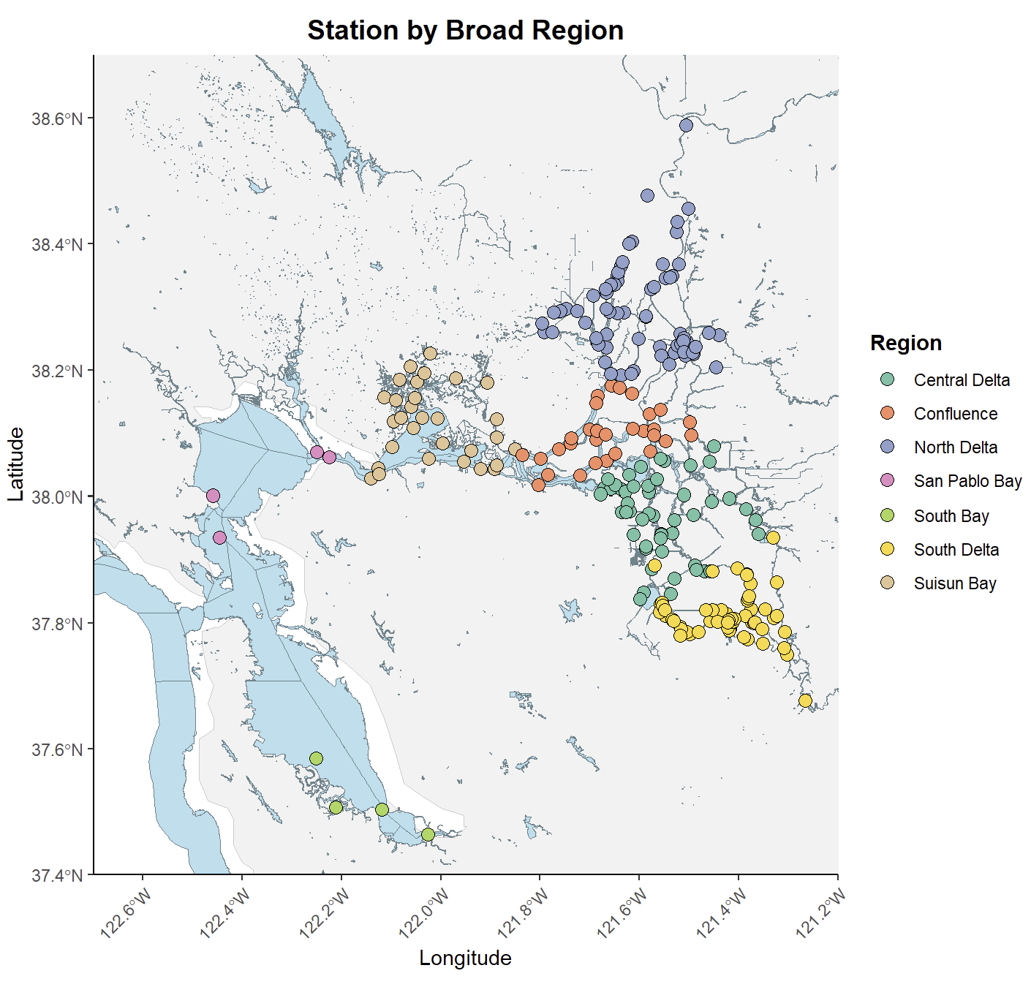
Figure 1. Map of points delineated by estuarine sub-region for tired outflow analysis. Central Bay Points were omitted from the dataset.
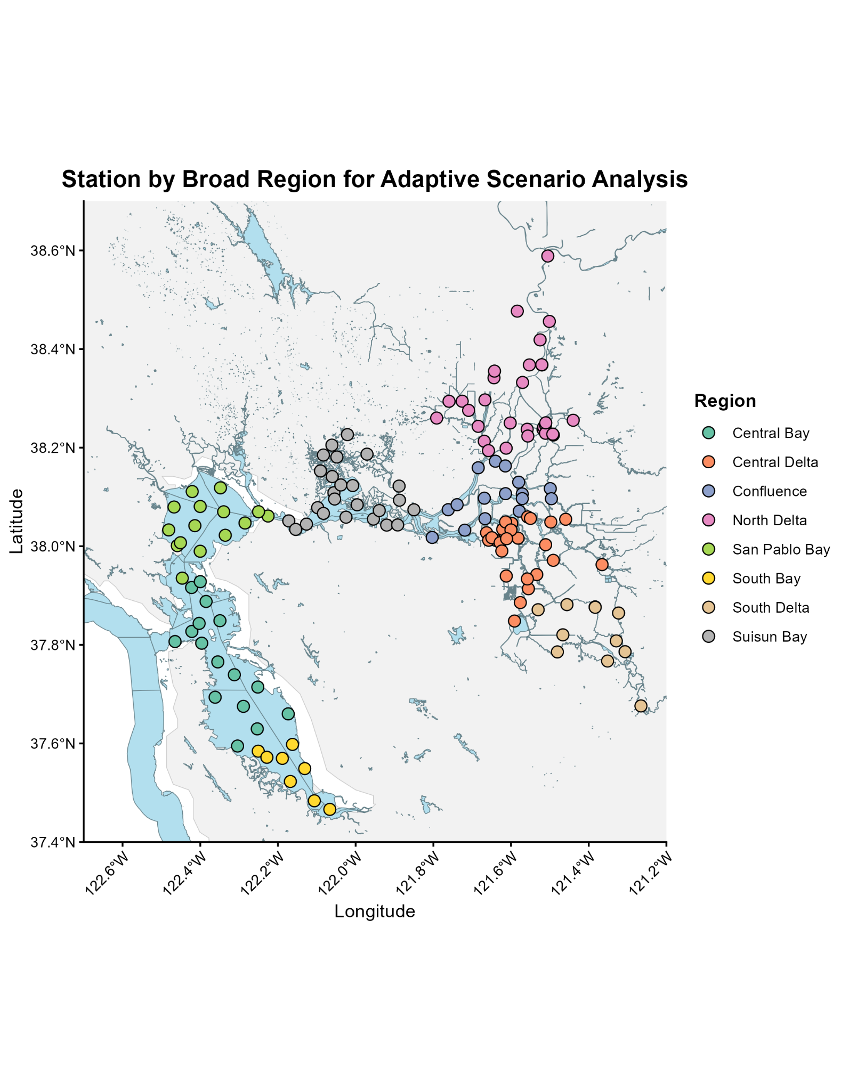
Map 2: Map of regions for the adaptive scenario analysis. N = 145

A note on mapmaking and justification:
For our region assignments for both the tiered outflow calculations and the adaptive scenario calculations we assigned regions based off of Pien et al. 2024, which was also instrumental in determining suitability thresholds for many of our species. Pien et al. 2024 determined their regions by using a hierarchical clustering analysis using average daily temperature, with slight adjustments at the discretion of the authors. We believe that these regional assignments reflect other contemporary maps of regional determinations. Moreover, the spatial assignments determined by Pien et al. 2024 reflect a genuine clustering of data that create a replicable assignment of points that is based on an abiotic determinant. We believe that this method effectively removes arbitrary boundaries and anchors the analysis in a meaningful ecological context.

Regions west of Suisun, where Pien et al. 2024 ends, were determined by known points of contraction, summarized by Grimaldo et al. 2020 and presented below.

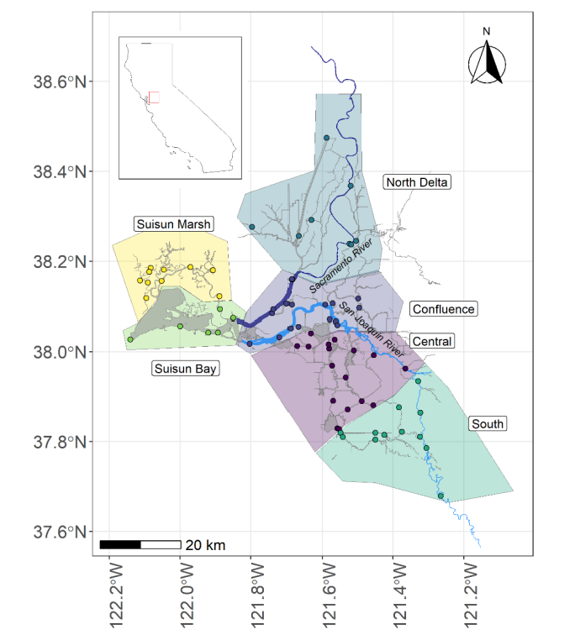
Figure 3: Pien et al. 2024 reference for regional assignment. Note: we combined Suisun Marsh and Suisun Bay in our regional assignments.

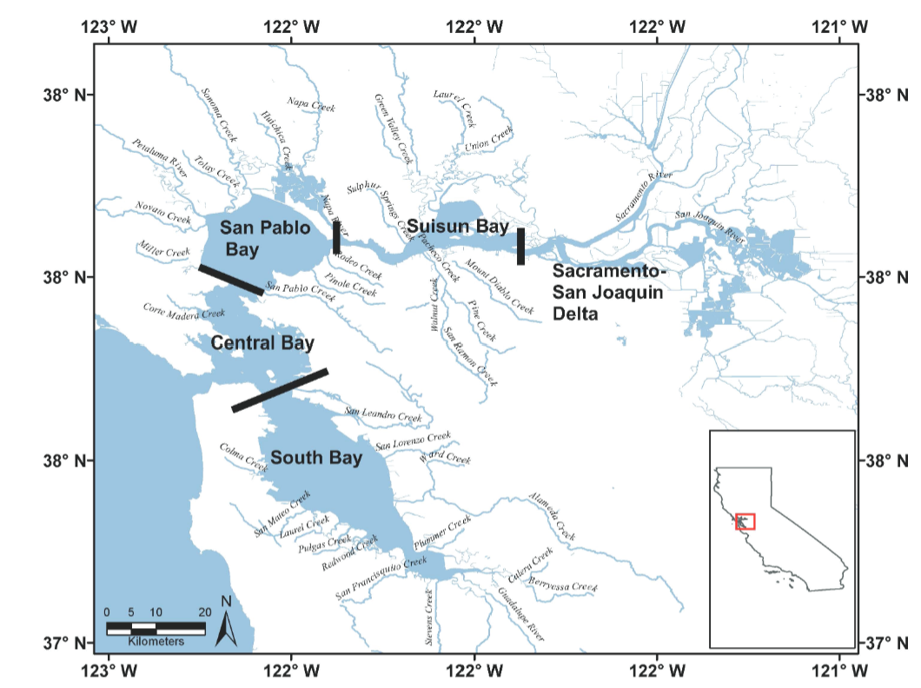
Figure 3: Grimaldo et al. 2020 map showing consistent regional assignments to estuary regions.

Species of Interest

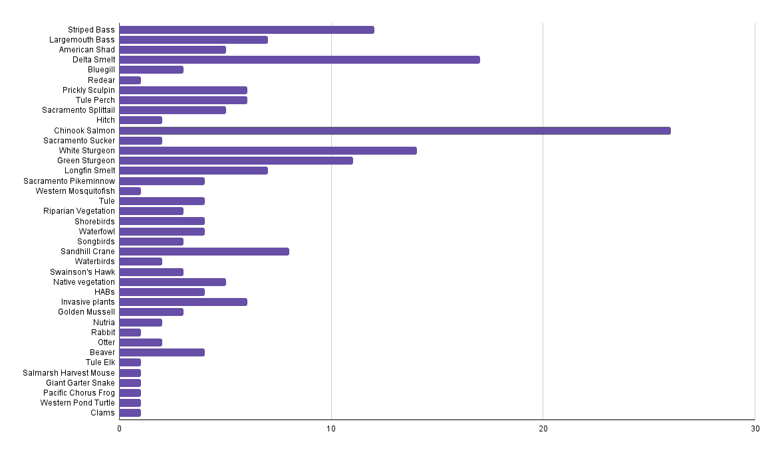
Figure 1: Survey results from the June 2025 stakeholder workshop where participants were asked to indicate which species in the San Francisco Estuary they were most interested in seeing how adaptation scenarios would impact their abundance.

We selected species based on stakeholder interest, sensitivity to temperature and salinity such that our modeling results may help indicate their functional abiotic niches, and captured a wide range of thresholds for suitability.

Species of interest:
- Longfin smelt juvenile - longfin smelt are a migratory, anadromous species. The adults migrate to freshwater reaches of the estuary to spawn. Larvae hatch in freshwater, then spend the first few weeks of life in fresh to brackish water before migrating to saltier regions.
- Longfin smelt adult - Adult longfin smelt migrate to freshwater to spawn, then vacate the fresh regions of the estuary for saltier areas, mostly within the Bay region itself rather than the eastern estuary. During the spring period captured in the model, post-spawning, adults who survived spawning are actively moving to saltwater.
- Egeria - Egeria densa is a non-native freshwater, submerged weed from South America that clogs waterways, decreases turbidity, and raises temperatures. In the SFE it has not been shown to be productive habitat for native or non-native fish species. It is a main culprit of landscape-level aquatic change in recent decades.
- Juvenile overbite clam - the overbite clam is a non-native planktivore (consuming both phytoplankton and microzooplankton) from Asia that has contributed to food web collapse in brackish regions. Adults are highly resilient to salinity swings, but juveniles require low to moderate amounts of salinity to survive and establish.
- Largemouth Bass - a non-native piscivorous fish from the Mississippi River drainage. In the SFE they are restricted to freshwater regions and have nearly no salinity tolerance (unlike individuals in their native range do). They do well in fresh, warm, conditions with some submerged vegetation.
- Striped Bass Juvenile - Striped bass are an introduced non-native piscivorous predator from the Eastern United States. Since their introduction in 1876 they have become naturalized in the system and are valuable sportfish. They are anadromous (salt to freshwater) spawners and juveniles are highly temperature sensitive.
- Striped Bass Adult - Like the juveniles, striped bass are anadromous and run up freshwater rivers in the Delta to spawn. They are temperature sensitive but have a wider threshold than the juveniles. They are highly prized sportfish.
- Juvenile Fall-Run Chinook Salmon - Chinook salmon are native, highly prized sportfish in the Delta. Adults spend the majority of their lives in the ocean, before migrating through the San Francisco Estuary to spawn on gravel beds in the Delta. Their populations are generally doing poorly because of anthropogenic alterations to the system. Juveniles migrate down from natal rivers and grow on floodplains in the Delta before migrating out to the ocean. Like striped bass they are anadromous, and are highly temperature sensitive.

Methods
What we are measuring:
- Proportion of total modeled days that salinity and temperature remained within species’ survival thresholds;
- Average “streak length” of consecutive days where conditions at a given point remain within survival thresholds. This represents changes in duration of suitable time according to the different runs or scenarios.

Origin of data:
Datasets:
Tiered Outflows:
- Historic Baseline
- 30% outflow increase from baseline
- 10% outflow decrease from baseline

Adaptation Scenarios:
- Business As Usual (Baseline)
- A Tunnel
- Eco Machine
- New Green Watershed
- Calling on Reserves
- Bolster and Fortify

Unit of measurement:
- For proportion of total suitable days: Suitable days/total number of days in model run
- For average streak lengths: Consecutive suitable days

Where are we measuring: Point locations across estuarine subregions (see map above)
Total run: 145 points
North Delta: 30 points
Central Delta: 23 points
South Delta: 11 points
Confluence: 16 points
Suisun Bay: 25 points
San Pablo Bay: 15 points
Central Bay: 16 points
South Bay: 9 points

Output data measurement: A score of 0 (unsuitable) or 1 (suitable) is assigned to each point, for each day, across the entire run. Those data are then used to calculate proportions of total suitable days and streak lengths.
Calculation:
- Proportion of total suitable days: We summed the number of suitable days (values of 1) and divided by the total number of days per run to calculate the proportion of total suitable days at each point. We then used beta regression models, within the R package “glmmTBB,” to assess how proportions of suitable days varied across adaptation or flow scenarios, years (wet vs. dry year), and estuarine subregions. The final model uses proportion of total suitable days as an outcome variable, with an interaction between scenario and subregion as predictors. To account for the effects of water year type, we created separate models for 2019 and 2020 for each species of interest.
- Average streak length: “Streaks” of suitable conditions were calculated by counting consecutive 1 (suitable) values noted at each point. The lengths of streaks at each point were then averaged. Streak lengths were not analyzed at the subregion level.
$Proportion of Suitable Days=\frac{\sum{}Suitable Days_{all sites}}{\sum{}Total Evaluated Days_{all sites}}$

Threshold: Thresholds were determined by referencing the literature (see references) on salinity and temperature tolerances for each species, beyond which survival is impossible:

Table 1: Physiological tolerance thresholds for species of interest.
Species | Salinity | Temperature
Egeria densa | < 5 psu | 3-26C
Largemouth Bass | < 4 psu | 3-28C
Juvenile Overbite Clam | 5 psu-25 psu | 3-26C
Juvenile Striped Bass | 0-35 psu | 12-27C
Juvenile Chinook Salmon | 0-35 psu | 10-25 C
Juvenile Longfin Smelt | 0.4-10 psu | 9-15 C
Adult Longfin Smelt | 15-30 psu | 9-18 C

Results
Tiered Outflows
Clams
We found significant interactions between tiered outflow scenario and estuarine subregion in predicting the proportion of suitable days for overbite clams. The Confluence, Suisun Bay, and San Pablo Bay shifted in run 16 (representing a 30% increase in flow) compared to run 15 (baseline flow conditions): points in the Confluence and Suisun Bay were less frequently suitable for clams, while San Pablo Bay was more frequently suitable. Run 17 (representing a 10% decrease in flow) improved suitability in Suisun Bay and San Pablo Bay (Table 2).
These central regions of the estuary, already in or near the brackish zone, were the only subregions affected by tiered outflow variations. Under decreased flow conditions, conditions in San Pablo and Suisun became saltier and more favorable for clams. When flows increased, the Confluence and Suisun became prohibitively too fresh.
Average streak lengths, predictably, increased for clams under saltier conditions. Run 16 had the shortest average streak, while run 17 had the longest, with baseline conditions in between (table 7).

Table 2. Proportion of suitable days for overbite clams for each subregion, under 3 tiered outflow scenarios. Green indicates a statistically significant increase in proportion of suitable days relative to baseline; red indicates a statistically significant decline.
Tiered outflow run | Region | Proportion of suitable days per run
15 (baseline) | North Delta | 0
15 (baseline) | Central Delta | 0
15 (baseline) | South Delta | 0
15 (baseline) | Confluence | 0.056
15 (baseline) | Suisun Bay | 0.817
15 (baseline) | San Pablo Bay | 0.332
15 (baseline) | South Bay | 0.002
16 (30% increase) | North Delta | 0
16 (30% increase) | Central Delta | 0
16 (30% increase) | South Delta | 0
16 (30% increase) | Confluence | 0.009
16 (30% increase) | Suisun Bay | 0.523
16 (30% increase) | San Pablo Bay | 0.489
16 (30% increase) | South Bay | 0.006
17 (10% decrease) | North Delta | 0
17 (10% decrease) | Central Delta | 0
17 (10% decrease) | South Delta | 0
17 (10% decrease) | Confluence | 0.062
17 (10% decrease) | Suisun Bay | 0.843
17 (10% decrease) | San Pablo Bay | 0.378
17 (10% decrease) | South Bay | 0

Longfin Smelt (juvenile)
For juvenile longfin smelt, the Confluence and North Delta were responsive to tiered outflow variations. Run 16 increased the proportion of suitable days in both regions, while run 17 decreased suitability in the North Delta. Juvenile longfin, which thrive in very small concentrations of salt, likely saw their range improve in the upper estuary under fresher conditions (Table 3). Longfin smelt had the longest average consecutive suitable day streak during run 17 (Table 7).

Table 3. Proportion of suitable days for juvenile longfin for each subregion, under 3 tiered outflow scenarios. Green indicates a statistically significant increase in proportion of suitable days relative to baseline; red indicates a statistically significant decline.
Tiered outflow run | Region | Proportion of suitable days per run
15 (baseline) | North Delta | 0.029
15 (baseline) | Central Delta | 0.272
15 (baseline) | South Delta | 0.467
15 (baseline) | Confluence | 0.224
15 (baseline) | Suisun Bay | 0.439
15 (baseline) | San Pablo Bay | 0
15 (baseline) | South Bay | 0
16 (30% increase) | North Delta | 0.029
16 (30% increase) | Central Delta | 0.076
16 (30% increase) | South Delta | 0.448
16 (30% increase) | Confluence | 0.277
16 (30% increase) | Suisun Bay | 0.455
16 (30% increase) | San Pablo Bay | 0
16 (30% increase) | South Bay | 0
17 (10% decrease) | North Delta | 0.029
17 (10% decrease) | Central Delta | 0.386
17 (10% decrease) | South Delta | 0.471
17 (10% decrease) | Confluence | 0.277
17 (10% decrease) | Suisun Bay | 0.422
17 (10% decrease) | San Pablo Bay | 0
17 (10% decrease) | South Bay | 0

Longfin Smelt (adult)
Adult longfin smelt, which are much more salt-tolerant than juveniles, saw suitable habitat fluctuate across tiered outflow scenarios in San Pablo Bay, South Bay, and Suisun Bay, where all other estuarine subregions were consistently too fresh. In run 16, habitat was suitable less frequently in San Pablo Bay and Suisun compared to baseline, but more suitable in the South Bay. In run 17, both the San Pablo Bay and South Bay became too salty, and saw a decline in suitable habitat (Table 4). Average consecutive suitable days did not vary greatly across tiered outflow scenarios (Table 7).

Table 4. Proportion of suitable days for adult longfin for each subregion, under 3 tiered outflow scenarios. Green indicates an increase in proportion of suitable days relative to baseline; red indicates a decline.
Tiered outflow run | Region | Proportion of suitable days per run
15 (baseline) | North Delta | 0
15 (baseline) | Central Delta | 0
15 (baseline) | South Delta | 0
15 (baseline) | Confluence | 0
15 (baseline) | Suisun Bay | 0.112
15 (baseline) | San Pablo Bay | 0.708
15 (baseline) | South Bay | 0.181
16 (30% increase) | North Delta | 0
16 (30% increase) | Central Delta | 0
16 (30% increase) | South Delta | 0
16 (30% increase) | Confluence | 0
16 (30% increase) | Suisun Bay | 0.075
16 (30% increase) | San Pablo Bay | 0.497
16 (30% increase) | South Bay | 0.609
17 (10% decrease) | North Delta | 0
17 (10% decrease) | Central Delta | 0
17 (10% decrease) | South Delta | 0
17 (10% decrease) | Confluence | 0
17 (10% decrease) | Suisun Bay | 0.105
17 (10% decrease) | San Pablo Bay | 0.546
17 (10% decrease) | South Bay | 0.098

Brazilian Waterweed
Conditions became more suitable for Brazilian waterweed, a strictly freshwater invasive, during run 16 in the Confluence and Suisun Bay, as slightly brackish regions likely saw declines in salinity with the increased flows. Run 17 produced a decrease in suitable days within Suisun (Table 5). Like many other species, Brazilian waterweed had its highest average consecutive suitable days during run 17 (Table 7).

Table 5. Proportion of suitable days for Brazilian waterweed for each subregion, under 3 tiered outflow scenarios. Green indicates an increase in proportion of suitable days relative to baseline; red indicates a decline.
Tiered outflow run | Region | Proportion of suitable days per run
15 (baseline) | North Delta | 1
15 (baseline) | Central Delta | 1
15 (baseline) | South Delta | 1
15 (baseline) | Confluence | 0.943
15 (baseline) | Suisun Bay | 0.182
15 (baseline) | San Pablo Bay | 0
15 (baseline) | South Bay | 0
16 (30% increase) | North Delta | 1
16 (30% increase) | Central Delta | 1
16 (30% increase) | South Delta | 1
16 (30% increase) | Confluence | 0.999
16 (30% increase) | Suisun Bay | 0.476
16 (30% increase) | San Pablo Bay | 0
16 (30% increase) | South Bay | 0
17 (10% decrease) | North Delta | 1
17 (10% decrease) | Central Delta | 1
17 (10% decrease) | South Delta | 1
17 (10% decrease) | Confluence | 0.938
17 (10% decrease) | Suisun Bay | 0.156
17 (10% decrease) | San Pablo Bay | 0
17 (10% decrease) | South Bay | 0

Largemouth Bass
Proportions of suitable days for largemouth bass increased in the Confluence and Suisun Bay during run 16, as fresher conditions expanded downstream. Run 17 decreased the proportion of suitable days in Suisun, reversing that trend. The remainder of the estuary did not vary significantly, either too fresh or too salty consistently (Table 6). Across all subregions combined, the highest number of consecutive suitable days occurred during run 17, with very similar results from baseline (Table 7).

Table 6. Proportion of suitable days for largemouth bass for each subregion, under 3 tiered outflow scenarios. Green indicates an increase in proportion of suitable days relative to baseline; red indicates a decline.
Tiered outflow run | Region | Proportion of suitable days per run
15 (baseline) | North Delta | 1
15 (baseline) | Central Delta | 1
15 (baseline) | South Delta | 1
15 (baseline) | Confluence | 0.922
15 (baseline) | Suisun Bay | 0.09
15 (baseline) | San Pablo Bay | 0
15 (baseline) | South Bay | 0
16 (30% increase) | North Delta | 1
16 (30% increase) | Central Delta | 1
16 (30% increase) | South Delta | 1
16 (30% increase) | Confluence | 0.978
16 (30% increase) | Suisun Bay | 0.323
16 (30% increase) | San Pablo Bay | 0
16 (30% increase) | South Bay | 0
17 (10% decrease) | North Delta | 1
17 (10% decrease) | Central Delta | 1
17 (10% decrease) | South Delta | 1
17 (10% decrease) | Confluence | 0.912
17 (10% decrease) | Suisun Bay | 0.068
17 (10% decrease) | San Pablo Bay | 0
17 (10% decrease) | South Bay | 0

Table 7. Average consecutive suitable days across all subregions for species of interest.
Species | Tiered outflow run | Average consecutive suitable days | Maximum consecutive suitable days
Overbite Clam | 15 | 27.80833333 | 119
Overbite Clam | 16 | 23.09574468 | 119
Overbite Clam | 17 | 31.48181818 | 119
Brazilian Waterweed | 15 | 92.97445255 | 119
Brazilian Waterweed | 16 | 93.99295775 | 119
Brazilian Waterweed | 17 | 95.96212121 | 119
Longfin Smelt (adult) | 15 | 21.86842105 | 119
Longfin Smelt (adult) | 16 | 19.975 | 99
Longfin Smelt (adult) | 17 | 19.11111111 | 92
Longfin smelt (juvenile) | 15 | 24.24203822 | 73
Longfin smelt (juvenile) | 16 | 21.0647482 | 76
Longfin smelt (juvenile) | 17 | 25.4246988 | 76
Largemouth Bass | 15 | 97.12015504 | 119
Largemouth Bass | 16 | 89.98965517 | 119
Largemouth Bass | 17 | 97.34375 | 119

Adaptation Scenario Analysis
We ran a series of beta models where we assessed the proportion of suitable points at different sites in different estuary regions as a function of the interaction between region and scenario, with sites as a random effect (which means that the variation between sites themselves is considered in the model). Below we have distilled the significant effects of the proportion of suitable points for focal species as a function of region and scenario, separated out by the different water years.

Clams
In general, higher proportions of suitable days per run for clams occurred in Suisun Bay and San Pablo Bay – two brackish regions of the estuary – and in 2020, a dry year. During 2020, proportions of suitable days per run increased relative to 2019 in every estuarine subregion except San Pablo Bay. This occurred regardless of scenario.
Using only scenarios with no interactions for region, Eco Machine and New Green Watershed significantly increased the functional abiotic suitability of clams as compared to the Baseline Scenario. In 2020 (a dry year), no scenario was significantly different in proportion of suitable points as compared to the baseline.

Table 8. Proportion of suitable days for overbite clam for each subregion, under 5 adaptation scenarios. Green indicates a statistically significant increase in proportion of suitable days relative to baseline (Business as Usual) scenario within the same year (2019 or 2020). Red indicates a decline.
Adaptation Scenario | Region | Proportion of suitable days per run in 2019 | Proportion of suitable days per run in 2020
Business as Usual | North Delta | 0 | 0
Business as Usual | Central Delta | 0 | 0
Business as Usual | South Delta | 0 | 0
Business as Usual | Confluence | 0 | 0
Business as Usual | Suisun Bay | 0.046 | 0.482
Business as Usual | San Pablo Bay | 0.929 | 0.505
Business as Usual | Central Bay | 0.036 | 0
Business as Usual | South Bay | 0 | 0
Bolster and Fortify | North Delta | 0 | 0
Bolster and Fortify | Central Delta | 0 | 0
Bolster and Fortify | South Delta | 0 | 0
Bolster and Fortify | Confluence | 0 | 0
Bolster and Fortify | Suisun Bay | 0.046 | 0.482
Bolster and Fortify | San Pablo Bay | 0.929 | 0.502
Bolster and Fortify | Central Bay | 0.036 | 0
Bolster and Fortify | South Bay | 0 | 0
Eco Machine | North Delta | 0 | 0
Eco Machine | Central Delta | 0 | 0
Eco Machine | South Delta | 0 | 0
Eco Machine | Confluence | 0 | 0
Eco Machine | Suisun Bay | 0.046 | 0.522
Eco Machine | San Pablo Bay | 0.93 | 0.52
Eco Machine | Central Bay | 0.041 | 0
Eco Machine | South Bay | 0 | 0
New Green Watershed | North Delta | 0 | 0
New Green Watershed | Central Delta | 0 | 0
New Green Watershed | South Delta | 0 | 0
New Green Watershed | Confluence | 0 | 0
New Green Watershed | Suisun Bay | 0.046 | 0.521
New Green Watershed | San Pablo Bay | 0.928 | 0.516
New Green Watershed | Central Bay | 0.041 | 0
New Green Watershed | South Bay | 0 | 0

Streak lengths by species and year per scenario

Adaptation Scenario | Species of Interest | Average streak length 2019 | Average streak length 2020
Business as Usual | Longfin Smelt Juvenile | 2.76 | 3.93
Business as Usual | Longfin Smelt Adult | 7.13 | 4.33
Business as Usual | Overbite Clam Juvenile | 8.42 | 9.97
Business as Usual | Egeria | 82.92 | 61.69
Business as Usual | Largemouth Bass | 83.22 | 70.52
Business as Usual | Striped Bass Juvenile | 57.99 | 70.09
Business as Usual | Striped Bass Adult | 56.70 | 71.14
Business as Usual | Chinook Salmon Juvenile | 69.71 | 65.24
Bolster and Fortify | Longfin Smelt Juvenile | 2.78 | 3.93
Bolster and Fortify | Longfin Smelt Adult | 7.13 | 4.34
Bolster and Fortify | Overbite Clam Juvenile | 8.42 | 9.97
Bolster and Fortify | Egeria | 82.91 | 61.69
Bolster and Fortify | Largemouth Bass | 83.22 | 70.52
Bolster and Fortify | Striped Bass Juvenile | 58.83 | 70.08
Bolster and Fortify | Striped Bass Adult | 56.74 | 71.28
Bolster and Fortify | Chinook Salmon Juvenile | 69.65 | 65.24
Calling on Reserves | Longfin Smelt Juvenile | 2.63 | 3.45
Calling on Reserves | Longfin Smelt Adult | 9.19 | 5.59
Calling on Reserves | Overbite Clam Juvenile | 8.23 | 11.97
Calling on Reserves | Egeria | 84.71 | 60.36
Calling on Reserves | Largemouth Bass | 84.25 | 69.49
Calling on Reserves | Striped Bass Juvenile | 54.73 | 68.90
Calling on Reserves | Striped Bass Adult | 55.28 | 72.94
Calling on Reserves | Chinook Salmon Juvenile | 84.63 | 64.69
Eco Machine | Longfin Smelt Juvenile | 2.95 | 3.38
Eco Machine | Longfin Smelt Adult | 7.03 | 4.54
Eco Machine | Overbite Clam Juvenile | 8.48 | 10.32
Eco Machine | Egeria | 81.31 | 63.76
Eco Machine | Largemouth Bass | 82.15 | 69.66
Eco Machine | Striped Bass Juvenile | 57.54 | 70.51
Eco Machine | Striped Bass Adult | 55.43 | 71.77
Eco Machine | Chinook Salmon Juvenile | 69.25 | 65.35
New Green Watershed | Longfin Smelt Juvenile | 2.94 | 3.39
New Green Watershed | Longfin Smelt Adult | 7.02 | 4.24
New Green Watershed | Overbite Clam Juvenile | 8.39 | 10.26
New Green Watershed | Egeria | 81.29 | 63.63
New Green Watershed | Largemouth Bass | 81.60 | 68.83
New Green Watershed | Striped Bass Juvenile | 57.65 | 69.88
New Green Watershed | Striped Bass Adult | 55.37 | 71.91
New Green Watershed | Chinook Salmon Juvenile | 68.88 | 65.73

Juvenile Longfin Smelt
More suitable days for juvenile longfin smelt occurred in San Pablo Bay, Suisun Bay, and the South Delta, where salinities were slightly elevated enough to meet the lower tolerance threshold. During 2020’s dry year, conditions became less suitable for longfin smelt in San Pablo Bay, but more suitable in Suisun, suggesting that salinities in San Pablo exceeded 10 psu more frequently. No scenario without interactions with the region produced significant results, likely because the relative effects of the increases in San Pablo Bay are counteracted by the decreases in Suisun Marsh, which washes out any total effects in the model (Table 9).

Table 9. Proportion of suitable days for juvenile longfin smelt for each subregion, under 5 adaptation scenarios. Green indicates a statistically significant increase in proportion of suitable days relative to baseline (Business as Usual) scenario within the same year (2019 or 2020). Red indicates a decline.

Adaptation Scenario | Region | Proportion of suitable days per run in 2019 | Proportion of suitable days per run in 2020
Business as Usual | North Delta | 0.005 | 0.004
Business as Usual | Central Delta | 0.006 | 0
Business as Usual | South Delta | 0.062 | 0.072
Business as Usual | Confluence | 0 | 0.058
Business as Usual | Suisun Bay | 0.189 | 0.358
Business as Usual | San Pablo Bay | 0.137 | 0
Business as Usual | Central Bay | 0 | 0
Business as Usual | South Bay | 0 | 0
Bolster and Fortify | North Delta | 0.005 | 0.004
Bolster and Fortify | Central Delta | 0.006 | 0
Bolster and Fortify | South Delta | 0.062 | 0.072
Bolster and Fortify | Confluence | 0 | 0.057
Bolster and Fortify | Suisun Bay | 0.188 | 0.358
Bolster and Fortify | San Pablo Bay | 0 | 0
Bolster and Fortify | Central Bay | 0 | 0
Bolster and Fortify | South Bay | 0 | 0
Eco Machine | North Delta | 0.005 | 0.005
Eco Machine | Central Delta | 0.007 | 0
Eco Machine | South Delta | 0.062 | 0.073
Eco Machine | Confluence | 0 | 0.044
Eco Machine | Suisun Bay | 0.228 | 0.347
Eco Machine | San Pablo Bay | 0.138 | 0
Eco Machine | Central Bay | 0 | 0
Eco Machine | South Bay | 0 | 0
New Green Watershed | North Delta | 0.005 | 0.003
New Green Watershed | Central Delta | 0.006 | 0
New Green Watershed | South Delta | 0.062 | 0.073
New Green Watershed | Confluence | 0 | 0.044
New Green Watershed | Suisun Bay | 0.227 | 0.347
New Green Watershed | San Pablo Bay | 0.139 | 0
New Green Watershed | Central Bay | 0 | 0
New Green Watershed | South Bay | 0 | 0

Adult Longfin Smelt
In 2020 suitability increases for adult longfin in every subregion, compared to 2019. No scenario otherwise had a significant effect (Table 10).

Table 10. Proportion of suitable days for adult longfin smelt for each subregion, under 5 adaptation scenarios. Green indicates a statistically significant increase in proportion of suitable days relative to baseline (Business as Usual) scenario within the same year (2019 or 2020). Red indicates a decline.

Adaptation Scenario | Region | Proportion of suitable days per run in 2019 | Proportion of suitable days per run in 2020
Business as Usual | North Delta | 0 | 0
Business as Usual | Central Delta | 0 | 0
Business as Usual | South Delta | 0 | 0
Business as Usual | Confluence | 0 | 0
Business as Usual | Suisun Bay | >0.001 | 0.067
Business as Usual | San Pablo Bay | 0.424 | 0.651
Business as Usual | Central Bay | 0.56 | 0.01
Business as Usual | South Bay | 0.507 | 0
Bolster and Fortify | North Delta | 0 | 0
Bolster and Fortify | Central Delta | 0 | 0
Bolster and Fortify | South Delta | 0 | 0
Bolster and Fortify | Confluence | 0 | 0
Bolster and Fortify | Suisun Bay | >0.001 | 0.067
Bolster and Fortify | San Pablo Bay | 0.424 | 0.651
Bolster and Fortify | Central Bay | 0.56 | 0.01
Bolster and Fortify | South Bay | 0.507 | 0
Eco Machine | North Delta | 0 | 0
Eco Machine | Central Delta | 0 | 0
Eco Machine | South Delta | 0 | 0
Eco Machine | Confluence | 0 | 0
Eco Machine | Suisun Bay | >0.001 | 0.067
Eco Machine | San Pablo Bay | 0.415 | 0.649
Eco Machine | Central Bay | 0.012 | 0.012
Eco Machine | South Bay | 0.508 | 0
New Green Watershed | North Delta | 0 | 0
New Green Watershed | Central Delta | 0 | 0
New Green Watershed | South Delta | 0 | 0
New Green Watershed | Confluence | 0 | 0
New Green Watershed | Suisun Bay | >0.001 | 0.067
New Green Watershed | San Pablo Bay | 0.415 | 0.65
New Green Watershed | Central Bay | 0.564 | 0.012
New Green Watershed | South Bay | 0.507 | 0

Brazilian Waterweed
Conditions were more suitable for Brazilian waterweed in the Delta subregions, Confluence, and Suisun Bay–the only regions of the estuary where salinities reach freshwater conditions. During 2020, relative to 2019, Suisun, the South Delta, and San Pablo Bay showed declines in percentages of suitable days for Egeria.
In 2019, in Eco Machine and New Green Watershed the proportion of suitable points for egeria decreases in the Central Delta, driven by changes in Frank’s Tract (Table 11).

Table 11. Proportion of suitable days for Brazilian waterweed for each subregion, under 5 adaptation scenarios. Green indicates a statistically significant increase in proportion of suitable days relative to baseline (Business as Usual) scenario within the same year (2019 or 2020). Red indicates a decline.
Adaptation Scenario | Region | Proportion of suitable days per run in 2019 | Proportion of suitable days per run in 2020
Business as Usual | North Delta | 0.999 | 0.991
Business as Usual | Central Delta | 1 | 1
Business as Usual | South Delta | 0.997 | 0.978
Business as Usual | Confluence | 1 | 1
Business as Usual | Suisun Bay | 0.946 | 0.505
Business as Usual | San Pablo Bay | 0.018 | 0
Business as Usual | Central Bay | 0 | 0
Business as Usual | South Bay | 0 | 0
Bolster and Fortify | North Delta | 0.999 | 0.991
Bolster and Fortify | Central Delta | 1 | 0.991
Bolster and Fortify | South Delta | 0.997 | 0.978
Bolster and Fortify | Confluence | 1 | 1
Bolster and Fortify | Suisun Bay | 0.946 | 0.505
Bolster and Fortify | San Pablo Bay | 0.018 | 0
Bolster and Fortify | Central Bay | 0 | 0
Bolster and Fortify | South Bay | 0 | 0
Eco Machine | North Delta | 0.999 | 0.991
Eco Machine | Central Delta | 0.986 | 0.97
Eco Machine | South Delta | 0.997 | 0.978
Eco Machine | Confluence | 1 | 1
Eco Machine | Suisun Bay | 0.947 | 0.466
Eco Machine | San Pablo Bay | 0.02 | 0
Eco Machine | Central Bay | 0 | 0
Eco Machine | South Bay | 0 | 0
New Green Watershed | North Delta | 0.999 | 0.992
New Green Watershed | Central Delta | 0.986 | 0.97
New Green Watershed | South Delta | 0.997 | 0.978
New Green Watershed | Confluence | 1 | 1
New Green Watershed | Suisun Bay | 0.947 | 0.468
New Green Watershed | San Pablo Bay | 0.02 | 0
New Green Watershed | Central Bay | 0 | 0
New Green Watershed | South Bay | 0 | 0

Largemouth Bass
Similar to Brazilian waterweed, there were larger percentages of suitable days for largemouth bass in the freshwater reaches of the estuary (Delta, Confluence, and Suisun). In 2019, the beta models showed that suitability for largemouth bass decreased in the Central Delta for both Eco Machine and New Green Watershed, again due to elevated salinities within Franks Tract. In 2020, largemouth bass abiotic suitabilities decreased in Suisun under the scenarios Eco Machine and New Green Watershed. These two scenarios appear to create saltier conditions in Suisun during dry years as compared to what may be anticipated from the baseline (Table 12).

Table 12. Proportion of suitable days for largemouth bass for each subregion, under 5 adaptation scenarios. Green indicates a statistically significant increase in proportion of suitable days relative to baseline (Business as Usual) scenario within the same year (2019 or 2020). Red indicates a decline.
Adaptation Scenario | Region | Proportion of suitable days per run in 2019 | Proportion of suitable days per run in 2020
Business as Usual | North Delta | 1 | 0.998
Business as Usual | Central Delta | 1 | 1
Business as Usual | South Delta | 1 | 0.997
Business as Usual | Confluence | 1 | 1
Business as Usual | Suisun Bay | 0.931 | 0.411
Business as Usual | San Pablo Bay | 0.004 | 0
Business as Usual | Central Bay | 0 | 0
Business as Usual | South Bay | 0 | 0
Bolster and Fortify | North Delta | 1 | 0.998
Bolster and Fortify | Central Delta | 1 | 1
Bolster and Fortify | South Delta | 1 | 0.997
Bolster and Fortify | Confluence | 1 | 1
Bolster and Fortify | Suisun Bay | 0.931 | 0.411
Bolster and Fortify | San Pablo Bay | 0.004 | 0
Bolster and Fortify | Central Bay | 0 | 0
Bolster and Fortify | South Bay | 0 | 0
Eco Machine | North Delta | 1 | 0.998
Eco Machine | Central Delta | 0.99 | 0.981
Eco Machine | South Delta | 1 | 0.997
Eco Machine | Confluence | 1 | 1
Eco Machine | Suisun Bay | 0.927 | 0.34
Eco Machine | San Pablo Bay | 0.006 | 0
Eco Machine | Central Bay | 0 | 0
Eco Machine | South Bay | 0 | 0
New Green Watershed | North Delta | 1 | 0.998
New Green Watershed | Central Delta | 0.99 | 1
New Green Watershed | South Delta | 1 | 0.996
New Green Watershed | Confluence | 1 | 1
New Green Watershed | Suisun Bay | 0.928 | 0.342
New Green Watershed | San Pablo Bay | 0.006 | 0
New Green Watershed | Central Bay | 0 | 0
New Green Watershed | South Bay | 0 | 0

Chinook Salmon
There were also fewer suitable days in 2020 compared to 2019, across scenarios and subregions. Multiple subregions (South Delta, Confluence, Suisun Bay, and San Pablo Bay) became less frequently suitable for Chinook salmon in 2020 relative to 2019, while the Confluence and the North Delta became more frequently suitable for Chinook Salmon under Calling on Reserves.
In both 2019 and 2020, no interactions between scenarios or regions were significant for juvenile Chinook salmon. This is likely because the lower outflows did not regulate temperature at any of the sites between each scenario.

Table 13. Proportion of suitable days for chinook salmon for each subregion, under 5 adaptation scenarios. Green indicates a statistically significant increase in proportion of suitable days relative to baseline (Business as Usual) scenario within the same year (2019 or 2020). Red indicates a decline.
Adaptation Scenario | Region | Proportion of suitable days per run in 2019 | Proportion of suitable days per run in 2020
Business as Usual | North Delta | 0.888 | 0.741
Business as Usual | Central Delta | 0.811 | 0.667
Business as Usual | South Delta | 0.93 | 0.632
Business as Usual | Confluence | 0.955 | 0.714
Business as Usual | Suisun Bay | 0.931 | 0.763
Business as Usual | San Pablo Bay | 0.984 | 0.894
Business as Usual | Central Bay | 0.987 | 0.952
Business as Usual | South Bay | 0.914 | 0.714
Bolster and Fortify | North Delta | 0.888 | 0.741
Bolster and Fortify | Central Delta | 0.811 | 0.667
Bolster and Fortify | South Delta | 0.93 | 0.632
Bolster and Fortify | Confluence | 0.955 | 0.714
Bolster and Fortify | Suisun Bay | 0.914 | 0.763
Bolster and Fortify | San Pablo Bay | 0.984 | 0.894
Bolster and Fortify | Central Bay | 0.987 | 0.952
Bolster and Fortify | South Bay | 0.872 | 0.714
Eco Machine | North Delta | 0.888 | 0.741
Eco Machine | Central Delta | 0.797 | 0.65
Eco Machine | South Delta | 0.932 | 0.632
Eco Machine | Confluence | 0.957 | 0.717
Eco Machine | Suisun Bay | 0.932 | 0.756
Eco Machine | San Pablo Bay | 0.984 | 0.894
Eco Machine | Central Bay | 0.987 | 0.952
Eco Machine | South Bay | 0.872 | 0.715
New Green Watershed | North Delta | 0.887 | 0.74
New Green Watershed | Central Delta | 0.797 | 0.65
New Green Watershed | South Delta | 0.931 | 0.632
New Green Watershed | Confluence | 0.958 | 0.717
New Green Watershed | Suisun Bay | 0.903 | 0.757
New Green Watershed | San Pablo Bay | 0.984 | 0.894
New Green Watershed | Central Bay | 0.987 | 0.952
New Green Watershed | South Bay | 0.872 | 0.715

Adult Striped Bass
Using Beta models we found no significant associations between scenarios or regions and their influence on striped bass adult abiotic functional niche in our analysis (Table 14).

Table 14. Proportion of suitable days for adult striped bass for each subregion, under 5 adaptation scenarios. Green indicates a statistically significant increase in proportion of suitable days relative to baseline (Business as Usual) scenario within the same year (2019 or 2020). Red indicates a decline.
Adaptation Scenario | Region | Proportion of suitable days per run in 2019 | Proportion of suitable days per run in 2020
Business as Usual | North Delta | 0.808 | 0.964
Business as Usual | Central Delta | 0.854 | 0.959
Business as Usual | South Delta | 0.959 | 0.939
Business as Usual | Confluence | 0.821 | 0.993
Business as Usual | Suisun Bay | 0.852 | 0.95
Business as Usual | San Pablo Bay | 0.889 | 0.984
Business as Usual | Central Bay | 0.996 | 0.997
Business as Usual | South Bay | 0.964 | 0.925
Bolster and Fortify | North Delta | 0.808 | 0.964
Bolster and Fortify | Central Delta | 0.855 | 0.959
Bolster and Fortify | South Delta | 0.959 | 0.94
Bolster and Fortify | Confluence | 0.821 | 0.993
Bolster and Fortify | Suisun Bay | 0.852 | 0.95
Bolster and Fortify | San Pablo Bay | 0.889 | 0.984
Bolster and Fortify | Central Bay | 0.996 | 0.996
Bolster and Fortify | South Bay | 0.964 | 0.925
Eco Machine | North Delta | 0.808 | 0.964
Eco Machine | Central Delta | 0.852 | 0.939
Eco Machine | South Delta | 0.959 | 0.939
Eco Machine | Confluence | 0.821 | 0.993
Eco Machine | Suisun Bay | 0.855 | 0.95
Eco Machine | San Pablo Bay | 0.887 | 0.984
Eco Machine | Central Bay | 0.996 | 0.939
Eco Machine | South Bay | 0.964 | 0.925
New Green Watershed | North Delta | 0.808 | 0.964
New Green Watershed | Central Delta | 0.852 | 0.939
New Green Watershed | South Delta | 0.959 | 0.939
New Green Watershed | Confluence | 0.821 | 0.993
New Green Watershed | Suisun Bay | 0.855 | 0.951
New Green Watershed | San Pablo Bay | 0.887 | 0.984
New Green Watershed | Central Bay | 0.996 | 0.997
New Green Watershed | South Bay | 0.964 | 0.925

Juvenile Striped Bass

Using beta models there were no significant associations between scenarios of regions and their proportion of suitable points in 2019. We also did not find significant differences between scenarios and regions in 2020 (Table 15).

Table 15. Proportion of suitable days for juvenile striped bass for each subregion, under 5 adaptation scenarios. Green indicates a statistically significant increase in proportion of suitable days relative to baseline (Business as Usual) scenario within the same year (2019 or 2020). Red indicates a decline.
Adaptation Scenario | Region | Proportion of suitable days per run in 2019 | Proportion of suitable days per run in 2020
Business as Usual | North Delta | 0.63 | 0.874
Business as Usual | Central Delta | 0.684 | 0.861
Business as Usual | South Delta | 0.773 | 0.902
Business as Usual | Confluence | 0.635 | 0.85
Business as Usual | Suisun Bay | 0.674 | 0.839
Business as Usual | San Pablo Bay | 0.673 | 0.867
Business as Usual | Central Bay | 0.715 | 0.893
Business as Usual | South Bay | 0.679 | 0.871
Bolster and Fortify | North Delta | 0.63 | 0.874
Bolster and Fortify | Central Delta | 0.684 | 0.861
Bolster and Fortify | South Delta | 0.773 | 0.902
Bolster and Fortify | Confluence | 0.635 | 0.85
Bolster and Fortify | Suisun Bay | 0.674 | 0.839
Bolster and Fortify | San Pablo Bay | 0.673 | 0.867
Bolster and Fortify | Central Bay | 0.715 | 0.893
Bolster and Fortify | South Bay | 0.679 | 0.871
Eco Machine | North Delta | 0.63 | 0.874
Eco Machine | Central Delta | 0.684 | 0.861
Eco Machine | South Delta | 0.773 | 0.902
Eco Machine | Confluence | 0.635 | 0.85
Eco Machine | Suisun Bay | 0.674 | 0.839
Eco Machine | San Pablo Bay | 0.673 | 0.867
Eco Machine | Central Bay | 0.715 | 0.893
Eco Machine | South Bay | 0.679 | 0.871
New Green Watershed | North Delta | 0.63 | 0.874
New Green Watershed | Central Delta | 0.684 | 0.861
New Green Watershed | South Delta | 0.773 | 0.902
New Green Watershed | Confluence | 0.635 | 0.85
New Green Watershed | Suisun Bay | 0.674 | 0.839
New Green Watershed | San Pablo Bay | 0.673 | 0.867
New Green Watershed | Central Bay | 0.715 | 0.893
New Green Watershed | South Bay | 0.679 | 0.871

Table 16. Summary table of proportion of suitable days for each species by year and adaptation scenario.

Species | Year | Business As Usual (BAU) | Eco-Machine (EM) | New Green Watershed (NGW) | Bolster & Fortify (BF)
Longfin Smelt Juvenile | 2019 | 5.31% / 2.76 d | 6.04% / 2.95 d | 6.02% / 2.94 d | 5.32% / 2.78 d
Longfin Smelt Juvenile | 2020 | 7.38% / 3.93 d | 7.06% / 3.38 d | 7.03% / 3.39 d | 7.38% / 3.93 d
Longfin Smelt Adult | 2019 | 13.29% / 7.13 d | 13.26% / 7.04 d | 13.25% / 7.02 d | 13.29% / 7.13 d
Longfin Smelt Adult | 2020 | 7.96% / 4.33 d | 7.97% / 4.54 d | 7.97% / 4.24 d | 7.96% / 4.34 d
Egeria | 2019 | 72.52% / 82.92 d | 72.33% / 81.31 d | 72.34% / 81.29 d | 72.52% / 82.91 d
Egeria | 2020 | 64.32% / 62.69 d | 63.30% / 63.76 d | 63.31% / 63.63 d | 64.31% / 62.69 d
Overbite Clam | 2019 | 10.72% / 8.42 d | 10.82% / 8.48 d | 10.78% / 8.39 d | 10.72% / 8.42 d
Overbite Clam | 2020 | 13.41% / 9.97 d | 14.30% / 10.32 d | 14.24% / 10.26 d | 13.41% / 9.97 d
Striped Bass Juv | 2019 | 67.46% / 58.83 d | 67.44% / 57.54 d | 67.44% / 57.65 d | 67.47% / 58.83 d
Striped Bass Juv | 2020 | 86.68% / 70.08 d | 86.47% / 79.51 d | 86.50% / 69.88 d | 86.67% / 70.08 d
Striped Bass Adult | 2019 | 87.37% / 56.74 d | 87.36% / 55.43 d | 87.35% / 55.37 d | 87.38% / 56.74 d
Striped Bass Adult | 2020 | 96.54% / 71.28 d | 96.20% / 71.77 d | 96.20% / 71.91 d | 96.56% / 71.28 d
Chinook Salmon | 2019 | 90.95% / 69.65 d | 90.54% / 69.25 d | 90.52% / 69.88 d | 90.95% / 69.65 d
Chinook Salmon | 2020 | 75.86% / 65.24 d | 75.51% / 65.35 d | 75.49% / 65.73 d | 75.86% / 65.24 d
Largemouth Bass | 2019 | 72.16% / 83.22 d | 71.95% / 82.15 d | 71.95% / 81.60 d | 71.16% / 83.22 d
Largemouth Bass | 2020 | 63.13% / 70.52 d | 61.58% / 69.66 d | 61.61% / 68.83 d | 63.13% / 70.52 d

Adaptation Scenario Analysis – New Baseline, Calling on Reserves, A Tunnel

Proportion of Suitable Days Across Species of Interest, Year, and Scenario

Scenario | Year | Longfin Smelt Juv | Longfin Smelt Adult | Egeria | Juvenile Overbite Clam | Striped Bass Juvenile | Striped Bass Adult | Chinook Juv | Largemouth Bass
New CalSIM Base | 2019 | 0.03814367 | 0.03599809 | 0.9090114 | 0.03623649 | 0.6726796 | 0.8575969 | 0.9063891 | 0.9080579
 | 2020 | 0.09331652 | 0.02790038 | 0.7991803 | 0.12263556 | 0.8656999 | 0.9642970 | 0.7300599 | 0.7925599
Calling on Reserves | 2019 | 0.0364 | 0.0356 | 0.9094 | 0.0364 | 0.6730 | 0.8578 | 0.9054 | 0.9085
 | 2020 | 0.0932 | 0.0279 | 0.7988 | 0.1233 | 0.8662 | 0.9647 | 0.7300 | 0.7917
A Tunnel | 2019 | 0.03933566 | 0.03655435 | 0.9080579 | 0.03623649 | 0.6728385 | 0.8584711 | 0.9084552 | 0.9069453
 | 2020 | 0.09520807 | 0.02616646 | 0.8169136 | 0.10537516 | 0.8661728 | 0.9646910 | 0.7267497 | 0.8095050

Adaptation Scenarios - New Base, Calling on Reserves update, a tunnel - October 27, 2026
Average Streak Length of Suitable Days Across Species of Interest, Year, and Scenario

Scenario | Year | Longfin Smelt Juv | Egeria | Overbite Clam | Largemouth Bass | Striped Bass Juvenile | Striped Bass Adult | Chinook Juv | Longfin Adult
New CalSIM Base | 2019 | 2.903846 | 105.94712 | 1.322756 | 107.14343 | 57.44297 | 51.31338 | 82.00881 | 2.454567
 | 2020 | 4.609238 | 77.78786 | 11.109369 | 90.52953 | 72.09696 | 68.09279 | 64.06474 | 2.294872
Calling on Reserves | 2019 | 2.4495 | 105.9143 | 1.7702 | 107.1042 | 56.3468 | 51.3278 | 82.0995 | 2.6330
 | 2020 | 4.6489 | 77.7793 | 11.3415 | 90.5512 | 72.7933 | 68.6510 | 64.2346 | 2.2874
A Tunnel | 2019 | 2.895375 | 106.16010 | 1.175481 | 106.42228 | 57.08288 | 51.03758 | 80.70577 | 2.266346
 | 2020 | 4.466850 | 79.54734 | 6.917651 | 91.50705 | 72.79247 | 68.11106 | 64.95176 | 2.067308

Species of interest, proportion of suitable days by region within each scenario (left); average streak length by region within each scenario (right)

Longfin Smelt Juvenile

 | New Base |  | Calling on Reserves |  | A Tunnel
Central Bay | 0 | 0 | 0 | 0 | 0 | 0
Central Delta | 0.00486 | 0.59091 | 0.004863 | 0.5909 | 0.00486 | 0.5909
Confluence | 0.05734 | 2.225 | 0.056790 | 2.3417 | 0.0573388 | 2.256
North Delta | 0.006467 | 0.1571 | 0.006467 | 0.1571 | 0.0064668 | 0.15714
San Pablo Bay | 0.16461 | 15.16667 | 0.168724 | 15.5 | 0.16049 | 13.277
South Bay | 0 | 0 | 0 | 0 | 0 | 0
South Delta | 0.06322 | 3.54545 | 0.0647 | 3.625 | 0.065095 | 3.45682
Suisun Bay | 0.2374 | 13.4423 | 0.2313 | 12.1167 | 0.245397 | 13.35407

Longfin Smelt Adult
 | New Base |  | Calling on Reserves |  | A Tunnel
Central Bay | 0.2239 | 16.840 | 0.22469 | 18.8733 | 0.223868 | 15.420
Central Delta | 0 | 0 | 0 | 0 | 0 | 0
Confluence | 0 | 0 | 0 | 0 | 0 | 0
North Delta | 0 | 0 | 0 | 0 | 0 | 0
San Pablo Bay | 0.5075 | 35.47917 | 0.49657 | 34.9750 | 0.525377 | 35.20833
South Bay | 0.27984 | 34.0000 | 0.28395 | 34.5000 | 0.271605 | 33.000
South Delta | 0 | 0 | 0 | 0 | 0 | 0
Suisun Bay | 0.02101 | 1.17544 | 0.02123 | 1.1617 | 0.015378 | 0.5065789

Egeria

 | New Base |  | Calling on Reserves |  | A Tunnel
Central Bay | 0 | 0 | 0 | 0 | 0 | 0
Central Delta | 0.99514 | 104.56818 | 0.9953 | 104.5795 | 0.99495 | 104.5568
Confluence | 1 | 121.50 | 1 | 121.5000 | 1 | 121.5000
North Delta | 0.9949 | 109.69821 | 0.9950 | 109.7071 | 0.995003 | 109.707143
San Pablo Bay | 0.028807 | 0.86111 | 0.0329 | 0.8667 | 0.021948 | 0.73333
South Bay | 0 | 0 | 0 | 0 | 0 | 0
South Delta | 0.98803 | 101.38636 | 0.9877 | 101.3636 | 0.987654 | 101.3636364
Suisun Bay | 0.68941 | 65.35975 | 0.6885 | 65.2323 | 0.736842 | 70.791395

Overbite Clam

 | New Base |  | Calling on Reserves |  | A Tunnel
Central Bay | 0.05597 | 1.360 | 0.06091 | 1.3100 | 0.049383 | 1.10833
Central Delta | 0 | 0 | 0 | 0 | 0 | 0
Confluence | 0 | 0 | 0 | 0 | 0 | 0
North Delta | 0 | 0 | 0 | 0 | 0 | 0
San Pablo Bay | 0.78326 | 30.13889 | 0.78326 | 41.4333 | 0.794239 | 29.138889
South Bay | 0 | 0 | 0 | 0 | 0 | 0
South Delta | 0 | 0 | 0 | 0 | 0 | 0
Suisun Bay | 0.29738 | 28.9081 | 0.29825 | 28.9978 | 0.249946 | 17.257080

Striped Bass Juvenile

 | New Base |  | Calling on Reserves |  | A Tunnel
Central Bay | 0.82469 | 42.97500 | 0.8247 | 42.9750 | 0.824691 | 42.97500
Central Delta | 0.76356 | 88.2500 | 0.7636 | 89.4545 | 0.763749 | 88.52273
Confluence | 0.74540 | 73.4833 | 0.7457 | 72.2000 | 0.745679 | 73.5000
North Delta | 0.76058 | 45.12917 | 0.7610 | 45.4759 | 0.7602881 | 45.49315
San Pablo Bay | 0.75995 | 73.8333 | 0.7599 | 73.8333 | 0.759945 | 73.8333
South Bay | 0.78189 | 47.5000 | 0.7819 | 47.5000 | 0.78189 | 47.5000
South Delta | 0.83651 | 42.60985 | 0.8380 | 42.6553 | 0.8395062 | 42.70076
Suisun Bay | 0.7566 | 77.6909 | 0.7570 | 75.6777 | 0.7565519 | 77.69085

Striped Bass Adult

 | New Base |  | Calling on Reserves |  | A Tunnel
Central Bay | 1 | 121.5 | 1 | 121.5000 | 1 | 121.5
Central Delta | 0.9063 | 49.05985 | 0.9072 | 48.6735 | 0.907782 | 48.60189
Confluence | 0.90617 | 76.3333 | 0.9070 | 76.3833 | 0.9061728 | 76.33889
North Delta | 0.89198 | 52.29330 | 0.8923 | 53.2234 | 0.8921223 | 52.30223
San Pablo Bay | 0.9465 | 83.16667 | 0.9465 | 83.1667 | 0.947874 | 84.8333
South Bay | 1 | 121.5 | 1 | 121.5000 | 1 | 121.5
South Delta | 0.95137 | 61.2333 | 0.9525 | 61.5197 | 0.95361 | 60.44697
Suisun Bay | 0.89214 | 45.71184 | 0.8911 | 46.1504 | 0.892138 | 45.71184

Chinook Juvenile

 | New Base |  | Calling on Reserves |  | A Tunnel
Central Bay | 1 | 121.5 | 1 | 121.5000 | 1 | 121.5
Central Delta | 0.73008 | 62.43295 | 0.7282 | 62.6860 | 0.73176 | 60.80227
Confluence | 0.85295 | 93.4083 | 0.8529 | 93.4083 | 0.84883 | 96.17778
North Delta | 0.82407 | 64.99256 | 0.8239 | 65.2991 | 0.82378 | 67.25149
San Pablo Bay | 0.95885 | 91.63889 | 0.9588 | 91.6389 | 0.9588477 | 91.63889
South Bay | 0.96708 | 117.500 | 0.9671 | 117.5000 | 0.967078 | 117.500
South Delta | 0.77965 | 68.50530 | 0.7789 | 68.4735 | 0.778526 | 68.42803
Suisun Bay | 0.82673 | 65.67939 | 0.8265 | 65.6662 | 0.825644 | 60.95833

Largemouth Bass

 | New Base |  | Calling on Reserves |  | A Tunnel
Central Bay | 0 | 0 | 0 | 0 | 0 | 0
Central Delta | 1 | 121.50 | 1 | 121.5000 | 1 | 121.5
Confluence | 1 | 121.50 | 1 | 121.5000 | 1 | 121.5
North Delta | 0.99882 | 118.16071 | 0.9986 | 118.1518 | 0.998677 | 118.151786
San Pablo Bay | 0.00823 | 0.58333 | 0.01235 | 0.7222 | 0.0068587 | 0.416667
South Bay | 0 | 0 | 0 | 0 | 0 | 0
South Delta | 0.998129 | 115.840909 | 0.9981 | 115.8409 | 0.998504 | 115.863636
Suisun Bay | 0.65437 | 63.10495 | 0.6528 | 63.0479 | 0.6982889 | 63.83289

Adaptation Scenarios - Sea Level Rise

Sea Level Rise Scenario Analysis - Eco 10.15.2026

Results
Overall scenario proportions of days, under the sea level rise scenarios.

Scenario | Year | LFS juv | LFS Adult | Egeria | Overbite Clam Juv | SB Juv | SB Adult | Chinook | Largemouth Bass | Total days evaluated
Base SLR | 2019 | 0.0475 | 0.0376 | 0.9085 | 0.0359 | 0.6704 | 0.8567 | 0.8996 | 0.9067 | 12584
 | 2020 | 0.0965 | 0.0270 | 0.8023 | 0.1213 | 0.8614 | 0.9643 | 0.7322 | 0.7924 | 12688
Bolster and Fortify SLR | 2019 | 0.0483 | 0.0376 | 0.9085 | 0.0359 | 0.6703 | 0.8567 | 0.8991 | 0.9067 | 12584
 | 2020 | 0.0965 | 0.0270 | 0.8023 | 0.1213 | 0.8614 | 0.9642 | 0.7323 | 0.7924 | 12688
New Green Watershed SLR | 2019 | 0.0580 | 0.0377 | 0.9077 | 0.0373 | 0.6705 | 0.8572 | 0.8980 | 0.9049 | 12584
 | 2020 | 0.0900 | 0.0272 | 0.7889 | 0.1345 | 0.9645 | 0.9645 | 0.7301 | 0.7648 | 12688
Eco Machine | 2019 | 0.0580 | 0.0377 | 0.9078 | 0.0374 | 0.6705 | 0.8565 | 0.8984 | 0.9046 | 12584
 | 2020 | 0.0900 | 0.02719 | 0.7889 | 0.1350 | 0.863 | 0.9651 | 0.7310 | 0.7646 | 12688

Overall number of consecutive days per scenario, separated by year by sea level rise scenario
Scenario | Year | LFS juv | LFS Adult | Egeria | Overbite Clam Juv | SB Juv | SB Adult | Chinook | Largemouth Bass
Base SLR | 2019 | 2.757 | 2.913 | 105.869 | 2.210 | 63.388 | 53.338 | 63.977 | 105.798
 | 2020 | 6.070 | 2.175 | 80.273 | 11.529 | 77.776 | 68.784 | 67.007 | 91.705
Bolster and Fortify SLR | 2019 | 2.853 | 2.913 | 105.869 | 2.210 | 63.376 | 52.497 | 64.091 | 105.798
 | 2020 | 6.6070 | 2.175 | 80.273 | 11.529 | 77.776 | 68.782 | 67.022 | 91.705
New Green Watershed | 2019 | 3.2623 | 2.5128 | 104.5891 | 2.0698 | 63.6870 | 51.7976 | 64.2828 | 104.5725
 | 2020 | 5.3231 | 2.3013 | 79.5351 | 11.5042 | 76.9739 | 69.6280 | 68.2460 | 89.2738
Eco Machine | 2019 | 3.268 | 2.5138 | 105.186 | 2.0817 | 63.62596 | 51.31557 | 64.57376 | 104.5978
 | 2020 | 5.5308 | 2.3045 | 79.7330 | 11.8697 | 77.47970 | 69.21571 | 67.76445 | 88.8813

Species of interest, proportion of suitable days by region within each scenario (top); average streak length by region within each scenario (bottom)

Longfin Smelt Juvenile

 | Bolster and Fortify SLR | Base SLR | New Green Watershed SLR | Eco Machine SLR
Central Bay | 0.00  0.00 | 0.00  0.00 | 0.00  0.00 | 0.00  0.00
Central Delta | 0.0079  0.9545 | 0.0062  0.7500 | 0.010  1.182 | 0.010  1.2045
Confluence | 0.05816  2.295 | 0.0584  2.2997 | 0.0469  2.059 | 0.0475  2.3754
North Delta | 0.00279  0.0678 | 0.00279  0.06786 | 0.0028  0.06786 | 0.00294  0.0857
San Pablo Bay | 0.12209  4.1000 | 0.12209  4.1000 | 0.1276  4.23333 | 0.12346  3.75
South Bay | 0.00  0.00 | 0.000  0.000 | 0.0000  0.0000 | 0.000  0.000
South Delta | 0.0642  3.925 | 0.0643  3.8795 | 0.06547  3.9038 | 0.06547  3.904
Suisun Bay | 0.2809  18.4819 | 0.2809  18.48195 | 0.294996  17.4747 | 0.29478  17.8335

Longfin Smelt Adult

 | Bolster and Fortify SLR | Base SLR | New Green Watershed SLR | Eco Machine SLR
Central Bay | 0.2255  19.25 | 0.2255  19.2500 | 0.22881  19.025 | 0.22798  19.0333
Central Delta | 0.000  0.000 | 0.000  0.000 | 0.000  0.000 | 0.000  0.000
Confluence | 0.000  0.00 | 0.000  0.000 | 0.000  0.000 | 0.000  0.00
North Delta | 0.000  0.000 | 0.000  0.000 | 0.000  0.000 | 0.000  0.000
San Pablo Bay | 0.5254  39.194 | 0.5254  39.194 | 0.5240  41.556 | 0.5240  41.5556
South Bay | 0.3333  40.5000 | 0.3333  40.5000 | 0.3292  20.000 | 0.32922  20.000
South Delta | 0.000  0.000 | 0.0000  0.000 | 0.000  0.000 | 0.000  0.000
Suisun Bay | 0.01689  0.5305 | 0.01689  0.5395 | 0.0171  0.5548 | 0.01733  0.05614

Egeria

 | Bolster and Fortify SLR | Base SLR | New Green Watershed SLR | Eco Machine SLR
Central Bay | 0.00  0.00 | 0.00  0.00 | 0.000  0.000 | 0.000  0.00
Central Delta | 0.9968  110.21591 | 0.9968  110.2159 | 0.9968  110.2159 | 0.9968  110.2159
Confluence | 1.0000  121.500 | 1.000  121.500 | 1.000  121.5000 | 1.000  121.500
North Delta | 0.9953  110.557 | 0.9953  110.557 | 0.9943  110.1905 | 0.9953  110.5565
San Pablo Bay | 0.01646  1.000 | 0.01646  1.000 | 0.0178  0.9722 | 0.01783  0.97222
South Bay | 0.0000  0.000 | 0.000  0.000 | 0.000  0.000 | 0.000  0.000
South Delta | 0.9903  104.2500 | 0.9903  104.2500 | 0.9903  104.2500 | 0.9903  104.2500
Suisun Bay | 0.6948  62.464 | 0.6948  62.464 | 0.6569  57.485 | 0.6556  59.120

Juvenile Overbite Clams

 | Bolster and Fortify SLR | Base SLR | New Green Watershed SLR | Eco Machine SLR
Central Bay | 0.0461  2.11 | 0.0461  2.12 | 0.05185  1.500 | 0.0527  1.3667
Central Delta | 0.00  0.00 | 0.000  0.000 | 0.000  0.000 | 0.000  0.000
Confluence | 0.00  0.00 | 0.000  0.000 | 0.000  0.000 | 0.000  0.000
North Delta | 0.00  0.00 | 0.000  0.000 | 0.000  0.000 | 0.000  0.00
San Pablo Bay | 0.7984  51.861 | 0.7984  51.861 | 0.79835  50.2639 | 0.7984  50.26389
South Bay | 0.0000  0.00 | 0.000  0.000 | 0.000  0.000 | 0.000  0.000
South Delta | 0.000  0.00 | 0.000  0.000 | 0.000  0.000 | 0.000  0.000
Suisun Bay | 0.2930  28.8556 | 0.2930  28.8556 | 0.3318  28.8188 | 0.3331  29.8869

Striped Bass Juvenile
 | Bolster and Fortify SLR | Base SLR | New Green Watershed SLR | Eco Machine SLR
Central Bay | 0.8173  49.925 | 0.8173  46.925 | 0.8156  46.825 | 0.8156  46.825
Central Delta | 0.7645  84.477 | 0.7647  84.500 | 0.7637  84.053 | 0.76356  84.042
Confluence | 0.7394  89.833 | 0.7394  89.833 | 0.7394  88.050 | 0.7394  89.8333
North Delta | 0.7581  57.39 | 0.7581  57.3902 | 0.7577  57.6161 | 0.7578  57.533
San Pablo Bay | 0.7517  75.500 | 0.7517  75.50 | 0.7544  75.8333 | 0.7544  75.8333
South Bay | 0.7778  67.25 | 0.7778  67.2500 | 0.7778  67.2500 | 0.7778  67.2500
South Delta | 0.8361  45.594 | 0.8361  45.595 | 0.8361  45.495 | 0.8361  45.595
Suisun Bay | 0.7492  78.7990 | 0.7492  78.7990 | 0.7559  78.9887 | 0.7553  78.9335

Striped Bass Adult
 | Bolster and Fortify SLR | Base SLR | New Green Watershed SLR | Eco Machine SLR
Central Bay | 1.000  121.500 | 1.000  121.500 | 1.000  121.500 | 1.000  121.500
Central Delta | 0.9025  49.794 | 0.9027  49.803 | 0.9052  52.9102 | 0.9042  51.9076
Confluence | 0.9078  79.050 | 0.9078  78.4889 | 0.90727  78.4556 | 0.9073  78.4556
North Delta | 0.8882  50.103 | 0.8882  50.103 | 0.8873  49.8604 | 0.8879  48.99315
San Pablo Bay | 0.9492  84.889 | 0.9492  84.889 | 0.9492  84.8889 | 0.9492  84.8889
South Bay | 1.000  121.500 | 1.000  121.500 | 1.000  121.500 | 1.000  121.500
South Delta | 0.9536  58.712 | 0.9536  58.712 | 0.9536  59.606 | 0.9536  59.6061
Suisun Bay | 0.8965  52.259 | 0.8965  52.2588 | 0.8976  49.361 | 0.8973  49.3518

Chinook Salmon juvenile
 | Bolster and Fortify SLR | Base SLR | New Green Watershed SLR | Eco Machine SLR
Central Bay | 1.000  121.5 | 1.000  121.500 | 1.0000  121.50 | 1.000  121.50
Central Delta | 0.7391  61.962 | 0.7391  61.617 | 0.7413  60.892 | 0.7406  62.082
Confluence | 0.8381  71.2278 | 0.8395  71.2889 | 0.8384  74.794 | 0.8392  74.344
North Delta | 0.8069  45.693 | 0.8069  45.693 | 0.8048  46.7297 | 0.8075  45.6957
San Pablo Bay | 0.9698  117.833 | 0.9698  117.833 | 0.9698  117.833 | 0.9694  117.6667
South Bay | 0.9671  117.500 | 0.9671  117.500 | 0.9671  117.500 | 0.9671  117.500
South Delta | 0.7875  69.436 | 0.7875  69.436 | 0.7883  69.5136 | 0.7886  69.525
Suisun Bay | 0.8332  66.556 | 0.8332  66.556 | 0.8241  67.2825 | 0.8241  67.28246

Largemouth Bass
 | Bolster and Fortify SLR | Base SLR | New Green Watershed SLR | Eco Machine SLR
Central Bay | 0.000  0.00 | 0.000  0.000 | 0.000  0.000 | 0.000  0.000
Central Delta | 1.000  121.50 | 1.000  121.50 | 1.000  121.50 | 1.000  121.500
Confluence | 1.000  121.50 | 1.000  121.50 | 1.000  121.50 | 1.000  121.500
North Delta | 0.9987  118.152 | 0.9987  118.152 | 0.9985  118.8869 | 0.99868  118.1518
San Pablo Bay | 0.00412  0.250 | 0.00412  0.2500 | 0.00823  0.4444 | 0.00686  0.5000
South Bay | 0.000  0.00 | 0.000  0.000 | 0.000  0.000 | 0.000  0.000
South Delta | 0.9993  118.6818 | 0.9993  118.682 | 0.99925  118.6818 | 0.99925  118.6818
Suisun Bay | 0.6506  61.059 | 0.6506  61.0594 | 0.5694  49.939 | 0.56812  50.0085

Discussion:

We see that habitat suitability for the species of interest is largely driven by interannual variability (a dry year versus a wet year), as opposed to scenarios or SLR, which play more minor roles in the greater climatic context.

Bolster and Fortify is identical to the baseline scenario. New Green Watershed and Eco Machine, compared to the baseline, show localized habitat changes for focal species. Some regions remain identical to baseline, while others, particularly in the Confluence and Suisun Bay show more dramatic changes. This is likely due to those areas being pre-existing areas of high variability, making them more sensitive to changes in flow, precipitation, and scenario.

Low salinity species, such as egeria, decrease in suitability in areas like Suisun in 2020 as opposed to 2019, whereas brackish obligates like overbite clam increase in suitability.

Eco Machine can offer micro-refugia for species, such as the juvenile longfin smelt, as seen through increased streak lengths in areas like the Confluence Zone. Species with higher salinity requirements can decrease in abiotic suitability streak lengths under some restoration scenarios in regions like the South Bay.

Overall, we see that New Green Watershed and Eco Machine can modify hydrodynamics to create increased suitabilities for more brackish obligates, and decrease suitabilities for freshwater obligates, which are often undesirable species. Nature based strategies can therefore provide modest relief for pressures on euryhaline species in a highly altered estuary.

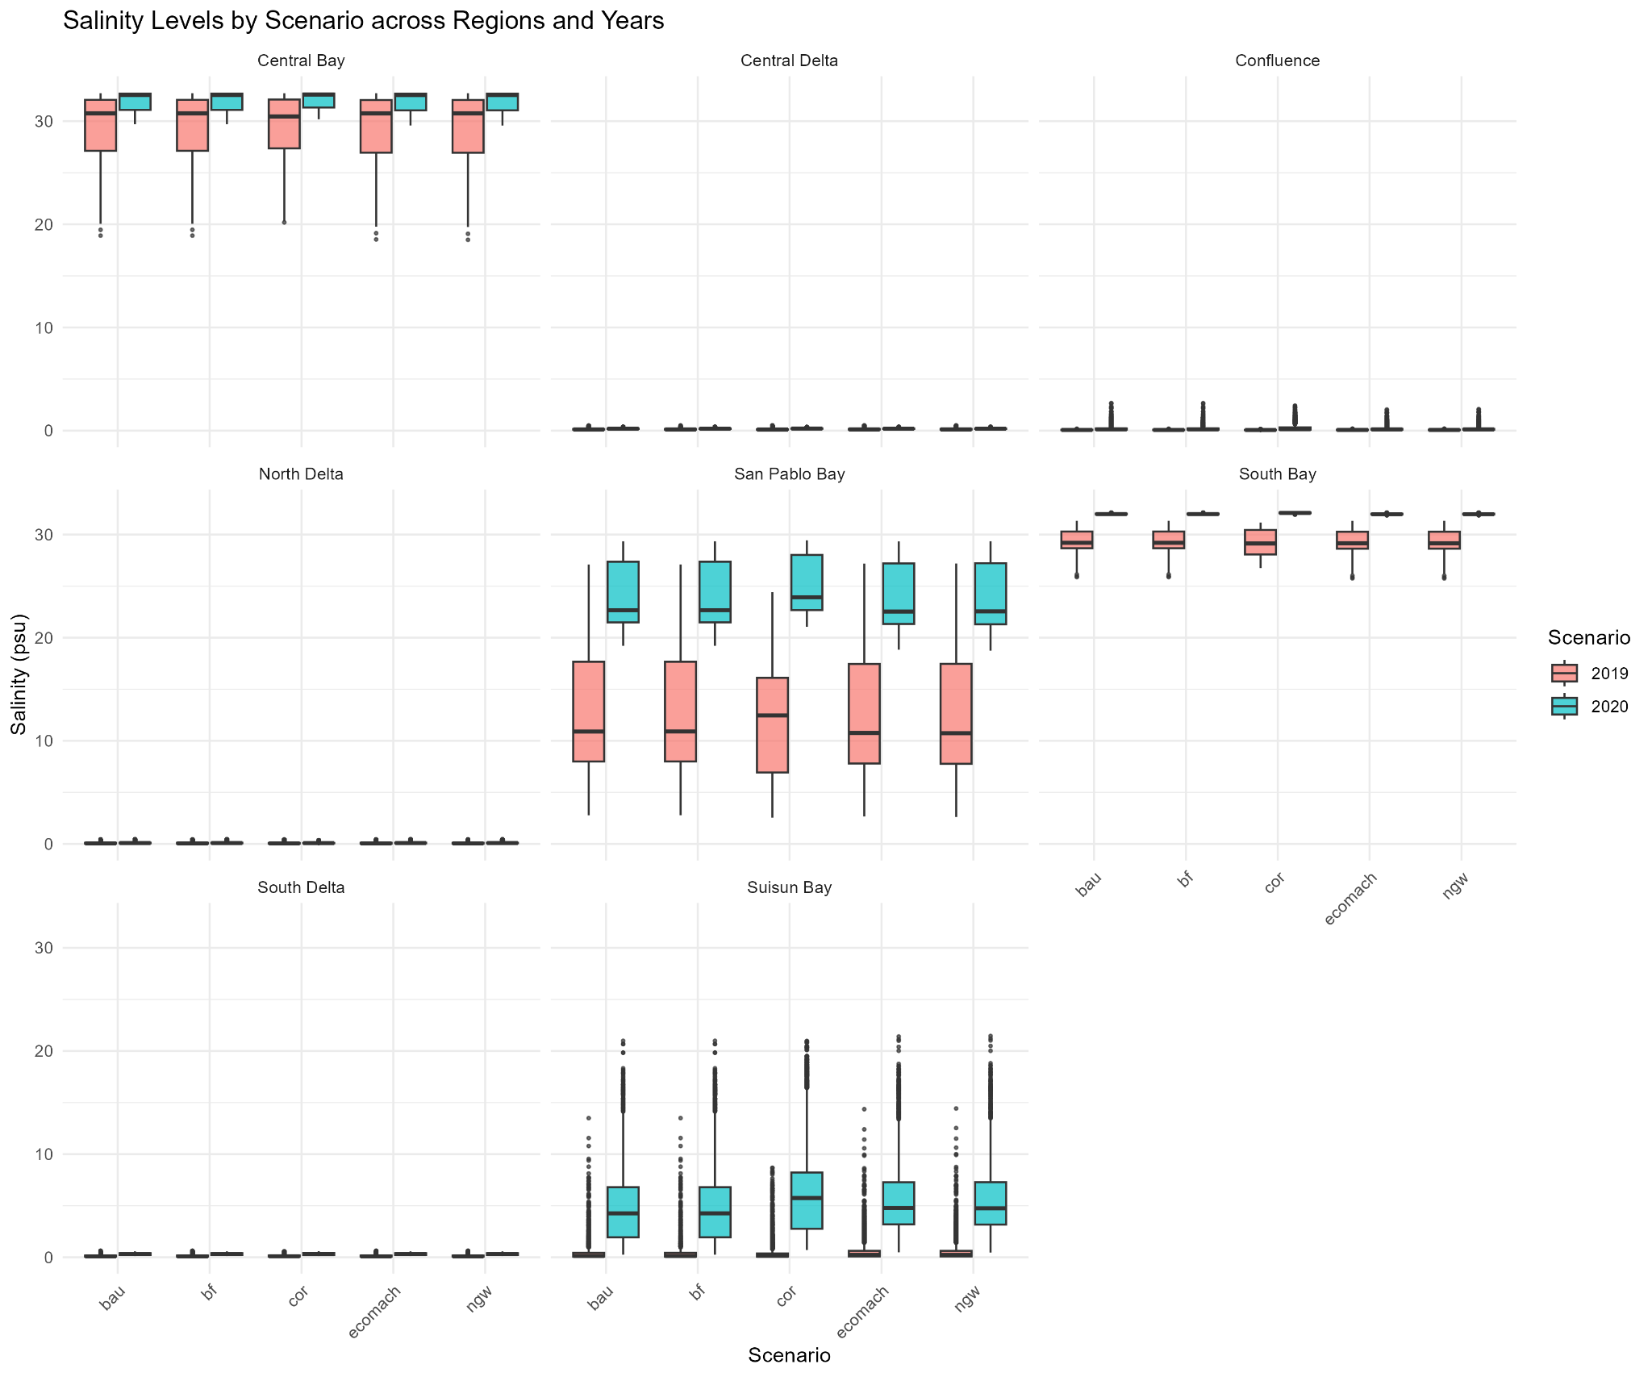
Salinity values by scenario across regions and years for reference for model outputs. 2019 represents a wet year and 2020 represents a dry year, with expected yearly variation that is slightly modified by scenario.
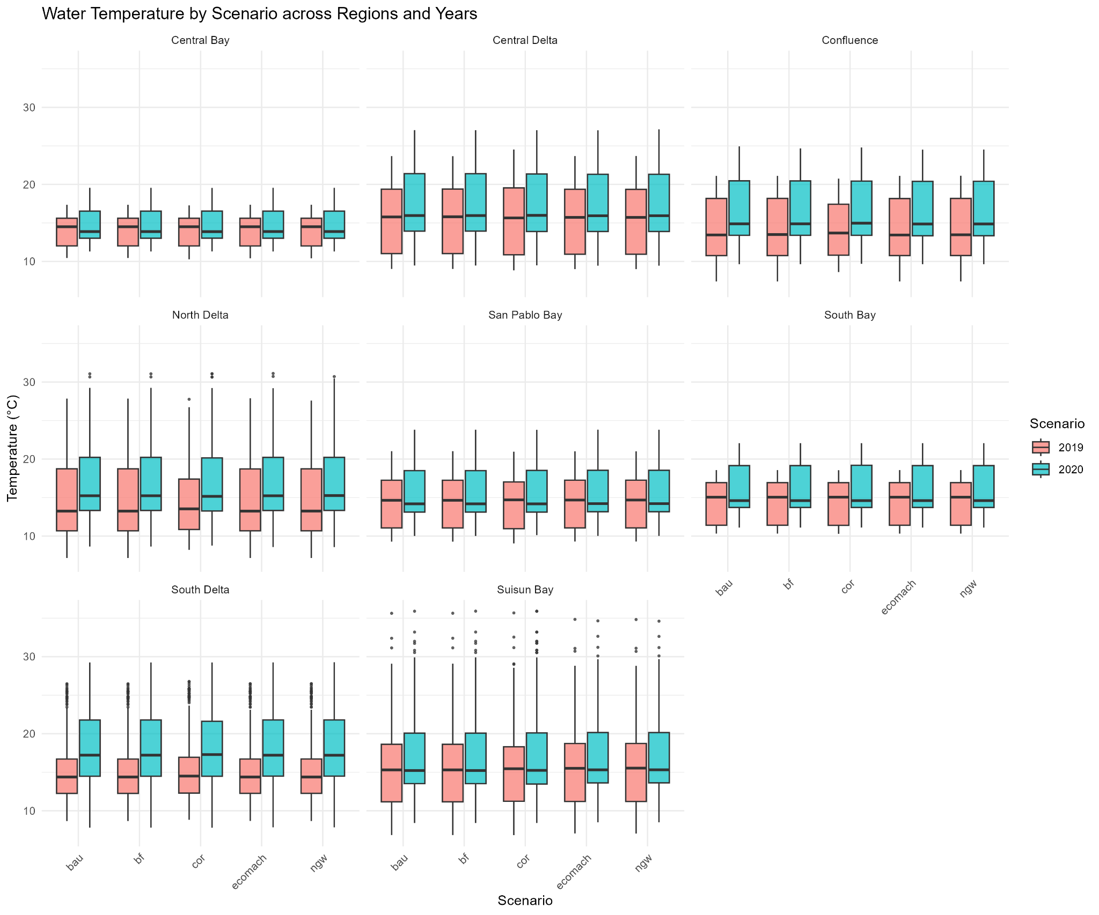

Total temperature per scenario and year to be used for contextualizing the modeling results and assessing the overall impact of the scenarios on temperature.

Metric: Pelagic Food Webs

We sought to assess how adaptation scenarios contributed to landscape-level changes in open-water food availability. Pelagic food is notoriously difficult to measure (see Lehman et al. 2015, Smits et al. 2023); therefore, we took the approach of assessing how much additional shallow-water habitat (managed and tidal wetland area) is contributed by each scenario relative to baseline, with the assumption that wetlands contribute to regional food availability (Lucas et al. 2006, Phillips et al 2026). We also assume additional wet soil agriculture can provide food resources similar to natural floodplains (Katz et al. 2017).

Methods
What we are measuring: Effects of increased wetted acreage compared to baseline on pelagic food webs

Origin of data: Mapping based on adaptation scenarios
Datasets:

Adaptation Scenarios:
- Eco Machine
- New Green Watershed
  - 100% restoration
  - 50% restoration, 50% wet soil agriculture
  - 25% restoration, 75% wet soil agriculture

NOTE: Only Eco Machine and New Green Watershed result in an increase in wetted acres on the landscape, so only these scenarios are evaluated.

Calculation: We summed additional wetted acres under each scenario, and multiplied the acres of each habitat type by a constant, determined by proportional contributions of each habitat type to food webs:

Total baseline managed wetland acres-5100*(0.2) + additional tidal wetland acres*(0.4)+ total wet soil ag acres-17,178*(0.1) = Proxy for food web production

Note that 5100 acres of managed habitat is subtracted, as those wetlands are converted to tidal habitat under both scenarios.

The total acreages of the three different landscape types are below:

Scenario | Total managed wetland acreage | Total additional tidal wetland acreage | Total wet soil ag acreage
Eco Machine | 5,100 (baseline) | 53,000 | 17,178 (baseline)
New Green Watershed 1 (100% managed) | 248,815 | 80,000 | 17,178 (baseline)
New Green Watershed 2 (50% managed, 50% wet soil ag) | 120,814 | 80,000 | 128,001
New Green Watershed 3 (25% managed, 75% wet soil ag) | 61,257 | 80,000 | 187,558

Results
Eco-Machine:
0 (0.2) + 53,000(0.4) + 0(0.1) = pelagic food web proxy for Eco Machine = 21,200

New Green Watershed
Sub-scenario 1: 100% managed wetlands on Delta Islands

248,815-5100 (0.2) + 80,000(0.4) + 0(0.1) = pelagic food web proxy NGW1 = 80743

Sub-scenario 2: 50% wet soil agriculture, 50% managed wetlands

120814-5100(0.2) + 80,000(0.4) + 128001-17178(0.1) = 23143+32000+14518 = 69661

Sub-scenario 3: 75% rice, 25% managed wetlands

61257-5100(0.2) + 80,000(4) + 187558-17178(0.1) = 11231+32000+17039 = 60270

RANK | 0 | 1 | 2 | 3 | 4 | 5 | 6 | 7 | 8 | 9 | 10
Eco-Machine |  |  |  |  |  |  | X
New Green Watershed 1 |  |  |  |  |  |  |  |  |  |  | X
New Green Watershed 2 |  |  |  |  |  |  |  |  |  | X
New Green Watershed 3 |  |  |  |  |  |  |  |  |  | X
Baseline and all other scenarios |  |  |  |  |  | X

We anchored our comparative scenario ranking with a baseline value of 5 (halfway between 1 and 10). All other scenarios except NGW and Eco Machine are also assigned a value of 5, because they represent no dramatic change in the overall landscape of the Delta. New Green Watershed subscenario 1 is our highest value food web proxy, and is therefore anchored at 10. Because the highest anchoring point is at a proxy of 80,743, the increments for increases in rankings are proxy values of 16,148. We rounded values to the nearest rank.

Metric: Accessible Aquatic Habitat
This was calculated simply by summing the total additional tidal wetland acres in each of our two restoration scenarios. The major difference between the two scenarios is that New Green Watershed restores a large portion of the Cache-Lindsay Slough Complex in the North Delta, a known hotspot for fish and food web activity. This restoration does not mediate salinity in those areas and was restored in the scenario solely for aquatic community benefit. This adds an additional ~27,000 to our restoration acreage.

In addition to habitat function, we also assessed the impacts of habitat acreage increases for species to access. This evaluates only tidal habitat, as managed wetlands and wet soil agriculture require periodic draining, so the habitat is not available year-round.

What we are measuring: Increased tidal wetland area compared to baseline

Origin of data: Mapping based on adaptation scenarios
Datasets:

Adaptation Scenarios:
- Eco Machine
- New Green Watershed

NOTE: Only Eco Machine and New Green Watershed result in an increase in wetted acres on the landscape, so only these scenarios are evaluated. The sub-scenarios of New Green Watershed also do not vary in tidal wetland acreage, so we did not evaluate them separately.

Calculation: We simply summed additional wetted acres under each scenario compared to baseline.

Results
NGW has approximately 80,000 new tidal wetland acres, while Eco Machine has about 53,000 newly accessible acres. We anchored the baseline at 5, along with the other scenarios that retain baseline acres of tidal wetlands. New Green Watershed is anchored at 10 as the scenario with maximal increases. Between a score of 5 and 10, there was an increase of 80,000 acres, meaning that scenario scores should increase by one step every 16,000 acres. Rounding to the nearest whole score, we therefore ranked Eco Machine at an 8.

Adaptation scenario ranking

RANK | 0 | 1 | 2 | 3 | 4 | 5 | 6 | 7 | 8 | 9 | 10
Business As Usual |  |  |  |  |  | X
Eco Machine |  |  |  |  |  |  |  |  | X
New Green Watershed |  |  |  |  |  |  |  |  |  |  | X
Bolster & Fortify |  |  |  |  |  | X
Calling On Reserves |  |  |  |  |  | X
A Tunnel |  |  |  |  |  | X

Implications and Discussion

Overall summary:
Tiered Outflows:
Run 15 (our baseline flow scenario), was our historical reference for the standard salinity and temperature gradients. Here we see that the brackish regions in our study are Suisun and San Pablo Bay, as is expected during most years. Under Run 16 we see that the freshwater boundary moves through the Confluence and into Suisun, following similar trends to what is experienced during typical wet years. Non-native juvenile overbite clams decrease in suitability within Suisun, but freshwater nuisance species, like Egeria increase in their number of suitable days, indicating increased freshwater stability systemwide. In Run 17 we see a higher proportion of suitable days and streaks of suitable days for overbite clam juveniles in Suisun, and reduces the freshwater area for low-salinity dependent species.

Comparisons Across Adaptation Scenarios
Adaptation - Bolster and Fortify

Overall, Bolster and Fortify varied little from the baseline (Business as Usual) scenario. No significant changes were observed for species fundamental niches. Also, no expansion of wetland habitat occurred under this scenario.

Adaptation - Eco Machine

Eco Machine primarily affected species fundamental niches by contracting the suitable habitat for several freshwater invasives – Brazilian waterweed and largemouth bass. The implementation of Frank’s Tract Futures increased salinity within the Central Delta region, which depressed suitability for those species. In terms of pelagic food webs, Eco Machine did slightly augment food production compared to baseline conditions by increasing tidal wetland habitat, but because it lacked the expansion of highly productive seasonal wetlands (managed and wet soil agriculture), it did not have as strong an effect on food web production as New Green Watershed. Without the inclusion of tidal restoration in the North Delta, it also did not expand as much accessible habitat as New Green Watershed (though it certainly provided an improvement from baseline).

Adaptation - New Green Watershed
New Green Watershed had similar effects on the fundamental niches of freshwater invasives as Eco Machine, and also slightly increased the proportion of suitable days for juvenile longfin smelt relative to baseline conditions. The biggest benefits of NGW are in its augmentation of food web production and accessible acres of habitat, multiplying the managed wetland acreage of the Delta and Suisun, depending on sub-scenario, by at least 10x.

CalSIM Base, Calling on Reserves, and a Tunnel
Adaptation - Calling on Reserves
We found that Calling on Reserves increases the streaks of Chinook Salmon and Longfin Smelt
Adaptation - A Tunnel

Restoration does matter but we are limited in where it can happen.Overall summary

Estuarine subregions, particularly those in the middle of the estuary — the Confluence, Suisun Bay, and San Pablo Bay regions — saw the most variation in species fundamental niche. The Delta remained consistently fresh across adaptation and tiered outflow scenarios, and the Bay consistently salty.
In terms of suitability for less desirable species, some tradeoffs were apparent across tiered outflow scenarios. Low-flow conditions

Justifications and Uncertainties
Regional Maps: In our regional maps, we included three regions within the greater Bay (the North Bay, Central Bay, and South Bay), despite the adaptation scenarios not being particularly impactful in these regions (they maintain stable temperatures and salinities). The incorporation of bay regions was to demonstrate that for many euryhaline species, alterations in salinities do not necessarily mean that those species decrease from the system as whole, and rather they move throughout the system, including into the San Pablo Bay and West.
Species of Interest Selection: We received many responses, and specific species, from stakeholders, during our June 2025 workshop. We could not incorporate many of the species of interest for our analysis because many would have required data that was our of the scope of this project. For some bird species, mammal species, herpetofauna species, and vegetation types, we would have needed data on specific habitat structure, water depth, and more minute changes in landscape that were beyond the scope of the project.
We specifically had to choose species that had known, and established physiologic thresholds for temperature and salinity that could be used to compare across different scenarios. This limited our species of interest selection to widespread, well-researched species. We included native species and non-native species of a variety of salinity tolerances.
Data Limitations for Adaptation Scenarios: It is critical to reiterate the limitations of connecting projected hydrodynamic data to trends of known species in a robust and informative manner. We chose to approach this from the perspective of functional abiotic niches, specifically where meets the minimum requirements for a species not to experience physiological stress. When a species does experience physiological stress it will likely move until it either perishes, or finds an area that does meet its physiological needs.
The data we are working with are daily maximum temperatures and salinities during the spring pulse flows and key spawning periods for our focal species of interest. Despite having acreage data regarding additional tidal wetland habitat per different adaptation scenarios, the details regarding this new wetland habitat were beyond the scope of this project. For that reason, and others, we were unable to assess any species-specific habitat usage, or other metrics of species' realized niches. Our results are simply meant to show abiotic thresholds, as opposed to actual predictions regarding where a species may exist in space and time.
Tiered Outflow Data Structure: Our tiered outflow models were constructed differently than our adaptation scenario and sea-level rise scenarios. In our initial analysis we omitted any species of interest that had a strict temperature threshold because some locations had suspicious temperature projections that the authors deemed to be misleading. This means that all our euryhaline species that were only limited by temperature (Chinook salmon, striped bass), were omitted from these models. We believe that the salinity data reflects true hydrodynamic patterns and conditions, but the discrepancies in the temperature data are cause for caution.
Moreover, the modeling results for Run 16 and Run 17 more closely resemble each other than either does to the baseline (Run 15) in terms of maximum salinity and temperature values at different specific point locations. It would be expected that Run 17 (10% decrease in “baseline” flows) would more closely resemble Run 15 (the “baseline”), as opposed to a 30% increase in flows (Run 16).
Residence Time in Food Web Models: Our food web modeling takes the most conservative but informative approach that we could design. The RMA modeling outputs do include residence time (measured by change from baseline run water ages), but those results were difficult to interpret in a quantitative way to incorporate into our general food webs model. Specifically, matching up residence time variations spatially with a generalized food web model involved too many assumptions to be incorporated in the final version of our model.

Overall rankings
- Calculate percentage change from baseline for each species-scenario combo for streaks and proportions
- Add percentages for each species (negative for bad species, positive for good species)

References
Delta Stewardship Council. (2026). Delta Plan Performance Measures: Acres of Natural Communities Restored Dashboard. State of California. Retrieved September 2026, from ca.gov

Agri-Pulse. (2026). Environmental group presses for more rice farming in the Delta. Agri-Pulse Communications, Inc. Retrieved September 2026, from agri-pulse.com

San Francisco Estuary Institute-Aquatic Science Center (SFEI-ASC). (2026). Delta Landscapes Primary Production Project. Richmond, CA. Retrieved September 2026, from sfei.org

Pien, C., Hartman, R., Bush, E., Lehman, P., & Davis, B. (2025). Thermal Stress and Suitability for Aquatic Species in the San Francisco Estuary. San Francisco Estuary and Watershed Science, 23(2)

Moyle, P. B. (2002). Inland Fishes of California (Revised and Expanded ed.). University of California Press.

Boyer, K., & Sutula, M. (2015). Factors Controlling Submersed and Floating Macrophytes in the Sacramento-San Joaquin Delta. Southern California Coastal Water Research Project (Technical Report 870).

Hardy, J. D. (1978). Development of fishes of the Mid-Atlantic Bight: An atlas of egg, larval and juvenile stages. U.S. Fish and Wildlife Service.

Carlton, J. T., et al. (1990). Remarkable invasion of San Francisco Bay by the Asian clam Potamocorbula amurensis. Marine Ecology Progress Series.

Parchaso, F., & Thompson, J. K. (2002). Influence of hydrologic processes on reproduction of the introduced bivalve Potamocorbula amurensis in the San Francisco Bay estuary. Marine Ecology Progress Series.

Myrick, C. A., & Cech, J. J. (2004). Temperature effects on juvenile anadromous salmonids in California's central valley: what don't we know? Reviews in Fish Biology and Fisheries.

Yanagitsiru, C. R., et al. (2021). Effects of Temperature and Salinity on the Physiological Performance and Growth of Larval and Juvenile Longfin Smelt. UC Davis / California Sea Grant Framework.

Rosenfield, J. A., & Baxter, R. D. (2007). Population dynamics and distribution patterns of longfin smelt in the San Francisco Estuary. Transactions of the American Fisheries Society.

Moyle, P. B., & Cech, J. J. (2000). Estuarine Fishes. In Fishes: An Introduction to Ichthyology (4th ed.). Prentice Hal

Kimmerer, W. J. (2004). Open water processes of the San Francisco Estuary: From physical forcing to biological responses. San Francisco Estuary and Watershed Science, 2(1).

Whipple

